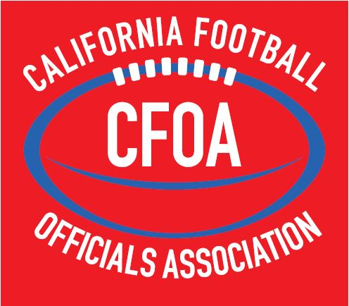

MECHANICS
MANUAL
2022 - 2023

CALIFORNIA FOOTBALL OFFICIALS ASSOCIATION
OFFICIALS MECHANICS MANUAL

Purpose of Manual

This manual was developed after reviewing several other football mechanics prepared by various local, regional, state and national officiating associations. Compromises were made in several areas to generate a system of mechanics that are relatively simple and can provide the best field coverage for games worked by the CFOA high school officials.

The manual provides descriptions of officiating excellence, uniform requirements, general mechanics, and signals as well as specific mechanics for a crew of five, four and three officials. Officials should concentrate on mastering the mechanics for a crew of five officials and then learn the differences and adjustments required to work with crews three or four.

The National Federation of State High Schools Associations (NFHS) Football Rules Book is the official rule book for the CFOA.

TABLE OF CONTENTS

 | SECTION | TITLE | PAGE NUMBER
 | 1 | GENERAL PRINCIPLES | 4 - 5
 | 2 | STANDARD UNIFORM | 6
 | 3 | OFFICIATING PROCEDURES | 7
 | 4 | PRE-GAME DUTIES ON THE FIELD | 8 - 9
 | 5 | COIN TOSS | 10
 | 6 | GENERAL GAME DUTIES | 11 - 13
 | 7 | TIMING | 14 - 15
 | 8 | USE OF BEAN BAG | 16 - 17
 | 9 | USE OF WHISTLE | 18 - 19
 | 10 | BALL HANDLING | 20 - 23
 | 11 | FREE KICKS | 24 - 25
 | 12 | KEYS | 26 - 33
 | 13 | PLAYS FROM SCRIMMAGE | 34
 | 14 | RUNNING PLAYS | 35 - 36
 | 15 | FORWARD PASSES | 37 - 38
 | 16 | GOAL LINE PLAYS | 39
 | 17 | FUMBLES | 40
 | 18 | SCRIMMAGE KICK – PUNTS | 41 - 43
 | 19 | TRY AND FIELD GOALS | 44 - 45
 | 20 | TIME OUTS | 46 - 47
 | 21 | MEASUREMENTS | 48 - 49
 | 22 | CALLING FOULS / ENFORCEMENTS | 50 - 52
 | 23 | CLOSE OF A PERIOD | 53
 | 24 | ONE-MINUTE INTERMISSION | 54
 | 25 | INTERMISSION BETWEEN HALVES | 55
 | 26 | OVERTIME | 56
 | 27 | OFFICIATING PHILOSOPHIES | 57 - 60
 | 28 | 4 PERSON MECHANICS | 61 - 75
 | 29 | 3 PERSON MECHANICS | 76 - 90

SECTION 1: GENERAL PRINCIPLES

- Knowledge of the Rules:
  - Rule mastery will be perfected over time and must be supplemented by the ability to learn and interpret rules and editorial changes correctly. These abilities are acquired through devotion of time and study.
- Physical Condition:
  - Football officiating is a difficult and exhausting endeavor which requires 100 percent efficiency of mind and body. An annual physical examination should be a personal requisite to ensure your health, thus allowing you to assess your ability to officiate.
- Mental Reactions:
  - Decisions must be instantaneous, and rulings made without delay. To ensure improved instinctive reaction during play situations, continue to review the different game situations and play scenarios which may occur.
- Duties and Responsibilities:
  - Each official must have a thorough knowledge of the duties of his own position as well as a general working knowledge of the duties of each of the other officials. They must be prepared to assume any one of the other positions whenever circumstances require rearrangement of assignments.
- An Official Must:
  - Know the down and yardage prior to each snap.
  - Be ready to assist any official that is temporarily out of position or had an obstructed view of a play.
  - Observe erroneous procedures or ruling by other officials and attempt to prevent and correct in an expeditious and diplomatic manner, whenever possible and under no circumstances should an argument develop on the field between officials
  - Know the correct signals and their proper use.
  - Secure a new ball when appropriate, after all action has ceased, and to handle and pass the ball properly.
  - Be alert to action away from the ball when play has left their immediate area.
  - Call time-out for any player who is obviously injured or disabled. Never rush the treatment of an injured player. Recognition of injured players is the concern of all game officials. The Game Clock can be started if a time-out is not necessary.
- Signals:
  - All signals should be given promptly, distinctly and conspicuously as they are the non-verbal communication tools we use to inform.
- Enforcement:
  - All rules should be strictly and fairly enforced. There shall be no deviation from the NFHS Football Rules.
- Hustle:
  - Keep the game moving smoothly from start to finish. Do not permit haste to interfere with duties or correct determinations.

- Boxing In:
  - Smart officiating requires keeping the players “boxed in” and avoidance of officials being “boxed in”. “Outside looking in” is essential for sideline and end line coverage. The ultimate goal is to have each play viewed from more than one direction.
- Off-Ball Officiating:
  - Officials should not be ball watchers. The official nearest the action should take the primary responsibility for the ball but should also be alert to action around the ball. The official that is the farthest away should take the widest “Big Picture” view of the action, looking for unsportsmanlike acts and threats to player safety. The officials in between should work in “Rings”. The closer you are to the ball, the smaller your “Ring” is.
- Cooperation:
  - Team work is essential amongst a crew of officials. If a ruling is puzzling, relay explanation to press box. Never issue direct or indirect newspaper interviews, statements, or stories concerning games in which you are an official. Continuous verbal and non-verbal communication between all officials during the game is essential for effective game administration. Officials should not post anything on Social Media regarding games, teams, coaches, players or other Officials.

SECTION 2: STANDARD UNIFORM

- Traditional Uniform:
  - It is essential that all CFOA football officials dress in a consistent manner. All members of a crew must be similarly dressed. For all varsity games the uniform worn by all officials shall include the following:
    - SHIRT – Standard black and white knit, long tail, 2¼ inch vertically striped officials’ long or short sleeve shirts with pocket on the left breast and complete with knit black “Byron” collar and black cuffs.
    - PANTS - The pants shall be full length black pants. The pants must include a 1¼ inch white strip on the seam of the leg, must not be cuffed, and must continue to the shoe without a break.
    - SOCKS – When wearing approved pants, officials will wear black socks.
    - SHOES AND BELT – Predominantly black shoes with black laces and appropriate soles or cleats. A black belt, a minimum of 1¼ inches and a maximum of 2 inches in width shall be worn.
    - CAP – Brooklyn style solid black cap with traditional narrow white piping (without emblem or numbers, other than small manufacturer’s logo) shall be worn by all but the Referee, who shall wear a Brooklyn style solid all-white cap (without emblem or numbers, other than small manufacturer’s logo). The cap shall be oriented with the bill facing forward and squarely covering the forehead of the official.
    - FOUL MARKER – All officials shall be equipped with at least one light gold foul marker, 15” x 15” and weighted in the center with pebbles, sand or beans and worn INCONSPICUOUSLY.
    - BEAN BAGS - All officials will be equipped with one or more white, blue, or black bean bags for marking spots. Bags shall be filled with pebbles, sand or beans. The entire crew must use the same color of bean bag.
    - JACKETS - Jackets are not considered part of the official uniform. EXCEPTION: Alternate Officials before entering the game.
    - UNDERSHIRTS – All undershirts which show should be black.
    - GLOVES – Gloves when worn shall be black.
    - EMBLEMS – A 2” x 3⅜” American Flag will be worn on the left chest ¼” above the pocket.
    - HELMETS – A protective helmet may be worn by the Umpire. When worn, helmets will be black, without a bill and must be fitted and secured with a black chin strap which must be secured when the ball is in play.
- Summer Uniform:
  - A “summer uniform” is approved for wearing in scrimmages and sub-varsity, in accord, but all in the crew must wear the same uniform. A “summer uniform” is a traditional uniform with black shorts with white crew socks that meet the bottom of the calf.

SECTION 3: OFFICIATING PROCEDURES

BEFORE ENTERING THE FIELD

ALL OFFICIALS:
All members of the officiating crew shall arrive no later than 1½ hours prior to the scheduled Kick-Off Time, to have time to dress, prepare for the game, and to participate in the Pre-Game Conference. The only acceptable excuse for being late for this Pre-Game Conference is in the case of an Emergency, provided the official has given notice to the Referee/Crew Chief.

- Back Judge
  - In the absence of the Referee, you are responsible to ensure that a pre-game conference is conducted.
- Back Judge
  - Make certain you have the correct time. Other officials will coordinate their watches with yours. The Play Clock should be kept along with a game clock, which may be either a field clock, or a wristwatch or stopwatch operated by the Back Judge. Assure you have an accurate timing device for timing the 40/25 second count.
- Referee
  - Conduct a thorough Pre-Game Conference outlining individual and crew duties. The purpose of a Pre-Game Conference is to prepare the crew mentally. It is important to solidify the thinking of officials in regard to procedures, rules, interpretations, philosophy and enforcements.
- Back Judge
  - Instruct clock operators.
- Referee and Umpire
  - Visit each team 1¼ hours prior to kickoff. Umpire inspects player equipment, braces, bandages, tape, and act. Remind head coach of equipment rule requirements and his certification that all players are legally equipped according to the rule. Additionally, the Referee may ask the head coach any unusual game situations. This may also take place on the field during your On-Field Pre-Game duties.
- All Officials
  - Leave the locker room together 30 minutes before kickoff.

SECTION 4: PRE-GAME DUTIES ON THE FIELD PROCEDURES

- All Officials
  - Arrive on the field as a crew 30 minutes before kickoff, or as soon as the crew is able.
  - Inspect the field for possible hazards and for correct markings. Notify game management of hazards and incorrect field markings. Hazardous situations must be resolved to the referee’s satisfaction before kickoff.
  - Once you have completed your assigned responsibilities, visually prepare yourself during team warm-ups by watching player actions similar to those you will see during the game.
  - Look for any illegal equipment and bring it to the attention of the umpire so it can be corrected before the game.
- Referee
  - With the umpire or another official, locate and meet each head coach separately. This may also be done one hour and fifteen minutes prior to game time or take place on the field during your On-Field Pre-Game duties.
  - Give the Head Coach the correct time-of-day and discuss the game timeline (toss, kickoff, half time).
  - Obtain information on captains and verify that all players are properly equipped. Ask about unusual plays or formations.
  - Explain the sideline policy and introduce the flank official that will be on his sideline.
  - If required, check to see that the medical staff is present.
  - Ask the home team coach or athletic director if overtime rules will be used in this game in the event of a tie.
  - Communicate the response to the visiting coach.
- Umpire
  - With the Referee, locate and meet each head coach separately.
  - Check player equipment and bandaging to ensure compliance with the rules.
  - Weather conditions may require a closer coordinated effort by you, the flank officials and the Back Judge in putting a new ball in play. Arrange it through the Line Judge. Ball persons are to remain off the field, except to retrieve the “old” ball on incomplete passes.
  - Approve the game balls.
- Head Linesman
  - Locate the members of the Chain Crew, chains and down box. Proceed with them to the sideline opposite the press box.
  - Make sure that the chain has a tape mark halfway between the stakes to assist with measurements.
  - Review responsibilities with chain crew and box man. Remind them they will be operating six feet back from the sideline at all times.
  - Introduce yourself to your ball persons and reinforce the Line Judge’s instructions.
  - Provide a spare beanbag to the box man for first and goal situations.
- Line Judge
  - Instruct ball boys and help inspect field.
  - Four minutes before kickoff, get captains and team (team on press box side) from their locker room in time for the coin toss three minutes before kickoff.

- Back Judge
  - Instruct the timer as to starting and stopping the clock. At the end of a quarter, no audible device may be used until the play is dead.
  - Confirm with the timer as to how time will be added to or taken from the clock.
  - Check for a phone or radio connection to the press box for communication with the time. Review if game management has a contingency plan for having a timer, or timing device. Review timeouts and be prepared to discuss media timeouts.
- Head Linesman and Line Judge
  - Identify “get back” coach before game to avoid sideline problems and warning.
  - Learn the names of ball persons.
  - Instruct ball persons as to their responsibilities and positioning. Remind ball persons they are to remain off the field and supply a ball to the nearest official as requested. It is unnecessary to replace the ball after each play (exception: foul weather).
- Back Judge and Line Judge
  - Have captains and teams from their locker room in time for the coin toss. This should occur no later than four minutes prior to kick off. Personally escort teams on to the field to keep teams separated until they go to their sidelines. This procedure is to be repeated after halftime.

SECTION 5: COIN TOSS

COIN TOSS PROCEDURE

The coin toss is normally conducted in the center of the field three minutes before the game.

The Referee escorts the home captains to the middle of the field. Most of the time, the home team will be on the press box side. If the teams are flipped, stay with the home team. The Umpire escorts the visiting captains. They proceed to the 45-yard lines with the Referee in position to face the scoreboard. The speaking captains (those who will give options for their teams) should be positioned so they are closest to the referee when the group meets in the center of the field.

The Head Linesman and Line Judge stand at the numbers on their sides of the field to keep players away from the toss. The Back Judge obtains the correct ball for the kickoff. The captains are asked to introduce themselves to each other.

The Referee should allow all captains to view both sides of the coin, identifying which side is heads and which is tails. The visiting captain is instructed to call heads or tails before the coin is flipped. The Umpire repeats the choice loudly enough for all to hear. The coin will be caught by the Referee and turned or not turned over. If the coin is dropped, the toss should be repeated. The Referee may choose to have the coin hit the ground.

Once the winner is determined, the winner is offered his choice: defer, receive, and choose a goal to defend or kick. If the choice is to defer, the Referee immediately faces the press box, taps the shoulder of the deferring captain and signals the declination. The remaining choices are then presented to the other captain and the final selection is made by the deferring captain. If the winner of the coin toss does not defer, no signal is immediately given.

When the final selections are made, the captains are asked to put their backs to the goal line their team will defend and the referee gives the appropriate signal. If the choice is to kick or receive, only the first selection is signaled. If the choice is to defend a goal, two signals are given: pointing both arms toward the goal line being defended, followed by the appropriate signal for the other captain.

If at any time during the toss the Referee errs or gives incorrect information (for instance, giving the wrong team an option), the Umpire should speak up immediately.

When the toss is completed, the other officials join the Referee and Umpire in the center of the field and record the results of the toss. All officials simultaneously move to their kickoff positions.

Before the second half kickoff, the flank officials should ask the head coach for his second-half choice. That will be done when getting teams to the field at the end of halftime.

SECTION 6: GENERAL GAME DUTIES

SUBSTITUTIONS AND COUNTING PLAYERS

All Officials are responsible for the legality of substitutions. The Referee and Umpire are responsible for the correct number of players on the offensive team and the Back Judge, Head Linesman and Line Judge is responsible for the correct numbers of players on the defensive teams.

- Free Kicks
  - The Referee and Umpire are responsible for the correct number of players on the receiving team and the Back Judge, Head Linesman and Line Judge is responsible for the correct number of players on the kicking team.
- All Officials
  - The fist signal will be used when the team you are counting has 11 players on the field. The open palm signal will be used when the team you are counting has fewer than 11 players on the field.

OTHER GENERAL GAME DUTIES – ALL OFFICIALS

Make written record of all charged time-outs and fouls you call. The position of ball at end of first and third periods, including down and distance, is the responsibility of the Referee, Head Linesman and Umpire. Back Judge is responsible for recording elapsed time and making certain the status of the clock is correct.

Convey any message you have for other officials promptly. Avoid any position that suggests a huddle of officials, unless necessary.

Be alert for players being out of bounds before a snap or free kick.

Watch for fouls, being certain to know:
Spot where run or scrimmage kick ended
Spot of foul, position or number of offending player
Whether, ball was loose, in possession or dead when the foul occurred
If the clock is stopped

Be ready for any type of play or unusual development. Always be prepared to rule on fumbles, illegal forward passes, and know which team possessed a fumble or backward pass before it went out of bounds between goal lines. On recovered fumbles, the official nearest to the recovery must rule on possession and promptly award the ball to the recovering team with a signal.

Be alert to rule on a dead ball behind a goal line. Indicate ruling by prompt signal.

Signal time-out (S3) when the rules provide for stopping the clock or when time-out is charged to a team or to the Referee. Repeat time-out signal of other officials.

Covering officials will use the dead ball signal (S7) when the play ends and there is no other reason to stop the clock.
A “winding” signal (S2) may be used when the ball becomes dead close to the sideline and the covering official rules that the ball remained inbounds. If an obvious first down has been made by Team A, the clock shall then be stopped.

Indicate, by touchdown signal (S5), when the ball is legally in possession of a player on or behind his opponent’s goal line. Referee check for any foul which might affect the ruling, if none, then relay the touchdown signal to the Press Box.

Check for false starts and feints.

Leave no doubt in the minds of players or other officials, as to any ruling you make.

Be especially alert for acts of misconduct.

PRE-SNAP DUTIES

- All Officials
  - Before each play, each official should work through their individual pre-snap duties. These duties include knowing the down and distance on each and every play. Additionally, individual officials are responsible for specific pre-snap duties that include, but are not limited to:
    - Referee
      - Count offense, signaling Umpire with 11 or less
      - Identify tackle as initial key for blocking
      - Identify backs or receivers that are outside of the tackle box, thus they cannot block below the waist.
      - Identify any numbering issues in the backfield, e.g. player in a 50-79 jersey that cannot be eligible for a pass
      - Establish a position 12 to 14 yards deep and 12 to 14 yards wide of the original position of the ball
    - Umpire
      - Cover the ball to prevent a snap prior to the ball being ready for play
      - Count offense, signaling Referee with 11 or less
      - Ensure five lineman numbered 50-79 are present and on the LOS (exception for Scrimmage Kick Formation)
      - Identify formation and strengths, lining up in a position to see the snap
      - Take a position 7 to 8 yards from the ball, clear of Team B players and in position to see the ball at the snap

    - Head Linesman
      - Ensure the correct down is on the down indicator
      - Count the team on defense. If team on your sideline is on defense, signal Back Judge using the approved signal for the number of players on the field
      - Identify the eligible receivers and keys on your side of the football
      - Identify if you have an unbalanced (more or less than three) line, signal the Line Judge
      - Rule on the eligibility of the lineman on your side of the football
      - Take a position on the line of scrimmage out of bounds, off the sideline
    - Line Judge
      - Ensure the correct down is on the down indicator and know the status of the clock
      - Count the team on defense. If team on your sideline is on defense, signal Back Judge using the approved signal for the number of players on the field
      - Identify the eligible receivers and keys on your side of the football by number
      - Identify if you have an unbalanced (more or less than three) line, signal the Head Linesman
      - Rule on the eligibility of the lineman on your side of the football
      - Take a position on the line of scrimmage out of bounds, off the sideline
    - Back Judge
      - Know clock status and ensure the play clock is started appropriately
      - Count the defensive team and signal the H or L as appropriate
      - Identify the receivers and strength of the formation based on your keys
      - Take a position approximately 20-25 yards from the line of scrimmage

Before the ball is put in play, adjust position as necessary to ensure you can clearly see your key and area of responsibility. There can be no excuse for failing to be in a good officiating position before the ball is put in play.

REFEREE

The Referee should move to the appropriate position where he can observe the offensive huddle. He should then check the down and distance with the Head Linesman and announce and indicate the new down. If play clock is to be started on the Referees’ signal, Referee should then declare the ball ready for play by sounding his whistle and giving ready signal (or wind the clock). Referee should only go to the line of scrimmage for non-routine events, close measurement, etc. Under unusual circumstances this pace of the game may vary and require discretionary slowing or speeding up action by the Referee. If, by rule, the clock should be started after Team A is awarded a first down, Referee will declare the ball ready for play by starting the game clock with a whistle when the point of the new series of downs has been established by Head Linesman and other officials are ready to resume play.

SECTION 7: TIMING PROCEDURE

GAME TIMING

Correct timing of the game is the responsibility of every official. Its importance cannot be overstated. All official have responsibility for stopping the clock as well as keeping it running. These responsibilities must remain consistent.

- Referee
  - Must be on the same page with the Back Judge at all times. The Back Judge will signal the Referee with 15 seconds remaining on team timeouts
  - Resetting the 25 second clock is your job. Use the raised and lowered open palm pumping motion to indicate to the Back Judge that a reset is necessary
  - Should you be facing the clock at the end of a quarter or half, do not allow a play to begin if time expires before the ball is live
  - In the event of a game clock malfunction, you will need to take responsibility for the 40/25 second clock
- Line Judge
  - Know the time on the clock; even though the clock is stopped, it may be incorrect and may require adjustment. Ensure the referee is aware of that and that you are prepared to correct it. Always correct the clock when it was not running and started in error. Any timing error more than five seconds outside of five minutes of each half shall be corrected and any timing error inside the five-minute mark shall be corrected. After enforcement of a penalty, ensure that the clock remains stopped or is started according to rule.
- Back Judge
  - You must have a watch or timing device capable of properly timing the entire game. All timing of the game is your responsibility. Should the game clock malfunction, you are to keep the time on the field. You may use the clock operator along the sideline to assist you. When 5 seconds remain in the 40/25-second count, raise one arm overhead and then lower your arm parallel and use a visual motion sideways to count down the last 5 seconds. (That mechanic will be used at the varsity level. If it is to be used in lower level games with crews of four, the Referee will be responsible.)
  - Should you be facing the clock at the end of a quarter or half, do not allow a play to begin if time expires before the ball is live.
  - On all timeouts, notify the crew when 15 seconds remain. The Flank Officials will notify their teams that the 25 second clock is about to start. The referee will signal the ball ready for play 15 seconds later.
  - Know the time on the clock; even though the clock is stopped, it may be incorrect and may require adjustment. Ensure the referee is aware of that and that you are prepared to correct it.
  - Always correct the clock when it was not running or started in error. Any timing error more than five seconds outside of five minutes of each half shall be corrected and any timing error inside the five-minute mark shall be corrected. After enforcement of a penalty, ensure that the clock remains stopped or is started according to rule.

TIMER INSTRUCTIONS

The official in charge of timing (Back Judge in a crew of five) should:

- Meet the timer, record his name on his game card and synchronize watches

- Determine timer’s location and discuss proper communication accordingly

- Discuss coordination of starting and stopping clock

- Determine how the clock will be reset, and if it can be reset to an exact time

- Set and begin pregame countdown, with the clock to hit 0:00 at game time

- Discuss length of halftime and let the clock operator know that you will signal when to begin

- Remind him that at the end of any quarter, no audible device may be used until the play clearly becomes dead. He should reset the clock only after the referee holds up the ball at the end of a quarter. If the period is extended for an untimed down, keep the clock at 0:00

- Remind the timer any official may stop the clock and that it doesn’t run on Point-After tries

- On plays near the boundary line the clock will continue to run, unless the official signals incomplete or stop the clock (out of bounds, first down, runners helmet came off, etc.).

- After a play in which the clock has been stopped, the referee may start it again by winding his arm. If no signal is given, the clock will start on the subsequent snap.

- The clock stops following a score or touchback after the appropriate signal has been made.

- For overtime, there will be no game clock, so please keep the clock at 0:00.

SECTION 8: USE OF BEAN BAGS

PROCEDURE

The bean bag is used to mark spots, other than the spot of a foul, which may later be needed as a reference point.

Bean bags are not to be thrown, they are to be dropped or tossed (seldom more than three yards).

On free kicks, all officials should have their beanbags in hand if needed to indicate a spot of first touching.

On scrimmage kicks, the Linesman, Line Judge and Back Judge should have beanbags in hand if needed to indicate a spot of first touching and the end of the kick.

Under no circumstances should the beanbag be used as a substitute for hustle. One common example of lazy officials using the beanbag instead of proper mechanics involves a play in which the runner is downed near or past a sideline. Some flank officials approach the players, throw their beanbag toward the spot and retrieve the ball from the runner.

It is not necessary to drop a beanbag at the spot a player intercepts a pass.

Unlike the spot of a fumble, that spot has no bearing on penalty enforcement.

SITUATIONS IN WHICH THE BEANBAG SHOULD BE USED

- Fumbles
  - The spot of the fumble must be marked in the event a penalty occurs and that spot is needed to determine where the run ended. Technically, the spot is required only for fumbles beyond the neutral zone, but many officials bag all fumbles out of habit.
- First Touching
  - During both free and scrimmage kicks, there are times when it is improper for Team K to touch a ball that has been kicked. That is known as “first touching” and it applies only when Team K touches the ball when it is not entitled to possession.
  - On free kicks, if Team K touches the ball before the ball crosses Team R’s free-kick line and before it is touched there by any Team R player, the spot must be marked with the beanbag. For a scrimmage kick, the spot must be marked if Team K touches the ball in the field of play beyond the line before Team R touches it.
  - The spot must be marked because Team R may have the right to take the ball at that spot.
- End of a Scrimmage Kick
  - If a scrimmage kick ends between the goal lines, the covering official must mark the spot with a beanbag. That is in case post-scrimmage kick enforcement (PSK) is needed on a foul.

- Momentum Exception
  - The momentum exception allows a defender or kick receiver to make a play without fear of giving up a safety.
  - When a defensive player intercepts an opponent’s forward pass; intercepts or recovers an opponent’s fumble or backward pass; or a Tem R player catches or recovers a scrimmage kick or free kick between his five yard line and the goal line, and his original momentum carries him into the end zone where the ball is declared dead in his team’s possession or it goes out of bounds in the end zone, the ball belongs to the team in possession at the spot where the pass or fumble was intercepted or recovered or the kick was caught or recovered.
  - The bean bagged spot might also be used to enforce a penalty that occurs after possession was obtained.
- Out of bounds
  - The beanbag can also be used to mark the out of bounds spot on punts. On free kicks, if the ball is kicked out of bounds untouched, it is a foul and the spot can be marked with the flag. The beanbag is useful when certain players go out of bounds during a play. If a player is pushed or blocked off the field, he may legally return and participate as long as he immediately re-enters; that spot does not need to be marked. However, if a player of Team A or Team K goes out of bounds before a change of possession, the spot should be marked. It is not a foul unless he returns and the return spot should then be marked with a flag. The beanbag will demonstrate the covering official was on top of the play.
- Inadvertent Whistles
  - When an official inadvertently blows his whistle, causing the ball to become dead, the covering official must drop his beanbag at the spot of the ball when the whistle was blown. The down may be replayed or the team in possession at the time the whistle was blown may choose to accept the result of the play.

SECTION 9: USE OF WHISTLE

ALL OFFICIALS

Each official will carry a whistle as part of required game equipment. A whistle on a lanyard is preferred. The lanyard should be black. Electronic and finger whistles are allowed as an alternative.

Whichever type of whistle is used, having a spare whistle in a pocket is recommended.

The Referee, Umpire, Head Linesman and Line Judge should strongly consider having the whistle in their mouths prior to the snap in case a dead-ball foul occurs or a team’s timeout request is granted. Once the snap occurs, it is strongly recommended that no official have a whistle in the mouth until the ball becomes dead.

Remember that, by rule, the whistle rarely causes the ball to become dead. Blowing the whistle only confirms that something has happened to cause the ball to become dead.

When, at the end of a down, any official sees that a flag has been thrown, he should alert the crew by giving three short blasts of the whistle. That helps ensure the box is not moved or the chains moved until the penalty is sorted out.

The Referee used the whistle to indicate the ball is ready for play, to start a new series after, there is a timeout (charged or official), there is a player injury and to prevent the ball from becoming live due to a dead-ball foul before the snap.

Rarely will the Referee use the whistle to confirm that the ball is dead after a play. It should take no more than three seconds to spot the ball and make it ready for play.

The Umpire whistles to indicate a timeout, dead-ball foul that prevents the snap and player injury. It is strongly recommended the Umpire refrain from using the whistle to confirm the ball is dead at the end of the play outside the hash marks. The Umpire may blow his whistle if he sees an incomplete pass in his coverage area, however.

Flank officials should not blow their whistles to mark the end of a play within hash marks, unless they see something unusual, such as a first down, turnover, and penalty, player losing their helmet, injury or a team calling a time out.

The Back Judge uses the whistle to indicate timeouts, injuries; the end of a quarter, touchback, the ball is dead in his coverage area and touchdowns when he is the covering official.

DECLARING THE BALL READY FOR PLAY

Communication with the quarterback regarding the status of the game clock at the ready-for-play is important during many intervals of the game. It is up to the Referee to use good judgment in keeping the quarterback informed in the regard and over-communicate if there is any doubt.

The Umpire should see that the ball is playable. If a towel is needed, carry one with you. In wet conditions you may hold the ball and not place it down until Team A comes to the line. If you request a new ball, it will be relayed to you by a Flank Official and/or the Back Judge, keeping the ball persons off the field.

In a hurry-up offense, the officials need to hustle but not to allow it to take over the pace. The Referee should not give the ready-for-play signal until the officials are ready. Let the quarterback know the status of the clock (starting on the ready or the snap). Be in position and signal the Umpire to go to his position before giving the ready. The Umpire straddles the ball, instructing the snapper not to touch the ball until the Referee blows his whistle. The Umpire backs out to his position when signaled by the Referee.

SECTION 10: BALL HANDLING

SCRIMMAGE PLAYS

- Back Judge, Head Linesman, and Line Judge
  - Meet and instruct Ball Person during on-field pre-game period. Ball Persons are to remain outside field of play at all times and be at least six feet off sideline unless relaying replacement ball or retrieving ball that has been replaced.
Note: Game officials are solely responsible for transferring replacement ball to Umpire for placement at the succeeding spot. Ball Persons are to remain off the field unless directed to retrieve a ball that has been replaced.
  - Ball Persons should be instructed to remain alert to relay a game ball in regardless of the situation.
  - Ball Persons should be instructed to pay attention to the official on his/her sideline. Ball Persons should be instructed to retain a towel for drying the ball.
  - Priority is always to get a replacement ball into the game; placing a ball at the foot of the official with forward progress must never delay getting the correct replacement ball into the game. For Field Goal attempts, Ball Persons are to be positioned at the Team B 10-yard line. For Tries, Ball Persons are to be positioned behind the end line. DO NOT PLACE REPLACEMENT BALL BY GOAL POST. Immediately following play, relay replacement ball to nearest official, then retrieve ball being replaced.

GENERAL BALL HANDLING

- Relaying Ball
  - Relaying or transferring of ball should be done quickly and efficiently, with as few exchanges as possible.
- Tossing Ball
  - All tosses shall be underhand, with a spiraling motion, and on a generally flat trajectory to chest level of person receiving ball. Do not toss ball over players. A crew proficient in ball handling will not allow ball to fall to ground while handling and transferring it.
- Start of Each Half or Extra Period
  - Flank officials are responsible to get the correct ball to the Back Judge to begin the second half or subsequent extra periods.

- Spotting Ball
  - Spotting the ball for the succeeding down should be done with one placement. The official that spots ball should do so as quickly as practical, yet assuring ball if placed correctly when first spotted. However, any official that has positive knowledge that ball if not spotted correctly should take necessary measures, including stopping clock, to get ball located correctly. An effective crew of CFOA officials will be expected to monitor the dead-ball action of the players while retrieving and placing the ball for the succeeding play. To provide better dead-ball coverage and better player safety, Referee, Back Judge and Flanks (when away from dead-ball spot) will focus more of their attention of the action of the players than on retrieving the dead-ball. While his represents a shift from traditional ball mechanics, the increased emphasis on player safety demand an approach based on effective coverage as well as efficiency. The Umpire will retrieve and spot the ball in most situations. There will be situations when Umpire goes outside the hash marks to retrieve the ball. When conditions permit, the Referee should assist the Umpire by moving to the succeeding spot and spotting the ball. Fluid coordination and communication between the Referee and Umpire will ensure the most efficient spotting of the ball. When the Umpire relays the ball to Referee, the Umpire should move into position for the next play. The Umpire will not go to the succeeding spot unless Team A is in a “hurry up” or “no huddle” offense.

WHEN THE BALL IS DEAD AND BETWEEN THE NINE-YARD MARKS:
Generally, the Umpire will retrieve the ball used on the previous play and place the ball at the appropriate spot. Nearby officials may be in a position to assist if doing so does not take them away from marking the dead-ball actions of the players.
- Umpire
  - When there is no further threat of foul, move to retrieve ball and place at the succeeding spot. The Umpire must be prepared to retrieve and spot any ball that is between the nine-yard marks.
- Referee
  - When there is no further threat of foul, and conditions permit, move to assist with retrieving the ball and delivering to Umpire to place at succeeding spot.
- Back Judge
  - Maintain depth and monitor players away from the ball. Back Judge will only rarely be involved in retrieving the ball, except in situations where an incomplete pass is in his proximity.
- Flanks
  - Indicate the dead-ball spot and mark with the downfield foot. Eyes should not be looking at the Dead-ball spot, rather, should be up and looking for illegal action by the players. Be prepared to assist Umpire in retrieving the ball. Observe the proper placement of the ball at the succeeding spot.

WHEN THE BALL IS DEAD OUTSIDE THE NINE-YARD MARKS, OR OUT OF BOUNDS:

Generally, a replacement ball will be used on plays that end outside the nine-yard marks on Team A’s sideline. When the ball becomes dead outside the nine-yard marks on Team B’s sideline, the ball from the previous play will be retrieved and placed at the succeeding spot.

Generally, Referee will retrieve the new ball and relay to Umpire who will place the ball at the inbounds spot. On long plays (more than 10-12 yards) Back Judge must be prepared to assist in relaying the ball to Umpire.

- Referee
  - Move to an open area between the inbounds line and the nine-yard marks. When there is no further threat of foul, retrieve the replacement ball and relay to Umpire who will spot the replacement ball.

- Umpire
  - When ball is dead following a play that ends outside the nine-yard marks, and there is no further threat of foul, move to the inbounds spot and receive the relay from Referee.
- Back Judge
  - Maintain depth to observe dead-ball and off-ball action of players. Following plays that gain more than 10-12 yards, be prepared to assist in retrieving the ball and relay to Umpire.
- Flanks
  - Indicate the dead-ball spot and mark with the downfield foot. Eyes should not be looking at the dead-ball spot, rather, should be up and looking for illegal action by the players. Be prepared to assist Referee or Umpire in retrieving the ball or obtaining a ball from the Ball Person. Observe the proper placement of the ball at the succeeding spot.

WHEN A FORWARD PASS IS INCOMPLETE:

- Flanks
  - If pass fails in such a manner that it can easily be re-used, when there is no further threat of a foul, retrieve the ball and relay to Umpire. If the pass fails in such a manner that it cannot easily be re-used, the Flank Official on Team A’s side will obtain a new ball from the Ball Person.
- Umpire
  - If pass fails in such a manner that it can easily be re-used, when there is no further threat of a foul, retrieve the ball and either place at the succeeding spot or relay to Referee. If the pass fails in such a manner that it cannot easily be re-used the flank official on Team A’s side will obtain a new ball from the Ball Person and relay to Umpire.
- Back Judge
  - Assist as necessary in getting replaced ball to appropriate Ball Person.
- Referee
  - Be prepared to receive a relay from Umpire and place at succeeding spot.

FOLLOWING PUNT OR MISSED FIELD GOAL:

- Back Judge
  - When there is no further threat of a foul, secure the ‘new offense’ ball from Ball Person on sideline of team now in possession and relay to Umpire. After relaying ball to Umpire, assist in getting replaced ball to appropriate Ball Person.
- Flanks
  - If you have forward progress and conditions permit, secure ball being replaced or a ‘spare’ ball from a Ball Person, and place at foot marking forward progress. This is to be done only if there is no threat of foul by any player, and if it does not distract any official from performing essential duties. Assist as necessary in getting replaced ball to appropriate Ball Person.

- Referee
  - Assist as necessary in getting replaced ball to appropriate Ball Person.

- Umpire
  - Move to an open area between the inbounds line and the nine-yard marks to sideline of team now in possession; when there is no further threat of foul, permit replacement ball to be relayed to you. Spot the ‘new offense’ ball.

SECTION 11: FREE KICKS

- Referee
  - Starting position is on the Head Linesman side of the field, on the bottom of the numbers on Team R’s goal line. Once he sees a ready signal from each official, the referee blows his whistle and gives the ready for play signal.
- Umpire
  - Starting position is on the Line Judge’s side of the field, on Team R’s 20 yard line. When in position and ready for the kick, raise an arm as a ready signal for the referee. Position may be adjusted if kicker has demonstrated a stronger leg.
- Line Judge
  - The Line Judge comes to the top of the numbers on his side of the field once the players are on the field. After identifying Team R’s free-kick line, the Line Judge reminds Team R that all blocks must be above the waist. The Back Judge and Line Judge turns towards each other, ensure that the other is ready, simultaneously jog off to their sidelines. Starting position is on the side opposite the chains, on Team R’s free-kick line. When in position and ready for the kick, raise an arm as a ready signal for the Referee.
- Linesman
  - Starting position is on the side of the field opposite the Line Judge, on Team R’s 30 yard line. When in position and ready for the kick, raise an arm as a ready signal for the Referee.
- Back Judge
  - The Back Judge moves toward the center of the field once the players are on the field. Do not give the ball to the kicker until Team K has 11 players on the field. Remind the kick not to kick the ball until the Referee has sounded his whistle. After identifying Team K’s free-kick line, turn toward the Line Judge. After ensuring that the other is ready, simultaneously jog off to their sidelines; the Back Judge is on Team K’s restraining line. When in position and ready for the kick, the Back Judge should raise an arm as a ready signal for the Referee. If the football falls or blows off the tee just prior to free kick, the Back Judge sounds whistle to prevent action and moves to kicker to give instructions.

FREE KICK AFTER SAFETY

All crew members take up the same positions and assume the same responsibilities as you would for a regular kickoff. The Referee’s and Umpire’s starting point will be determined by the type of kick used (punt or kickoff). Unless moved by penalty, the ball will be put in play at Team K’s 20 yard line.

FREE KICK AFTER FAIR CATCH

The Linesman sets the chains, which helps establish the 10 yards between team’s restraining lines. All crew members take up the same positions as on a regular kickoff, except the Referee and Umpire will position themselves under the goalpost uprights and will rule on the kick.

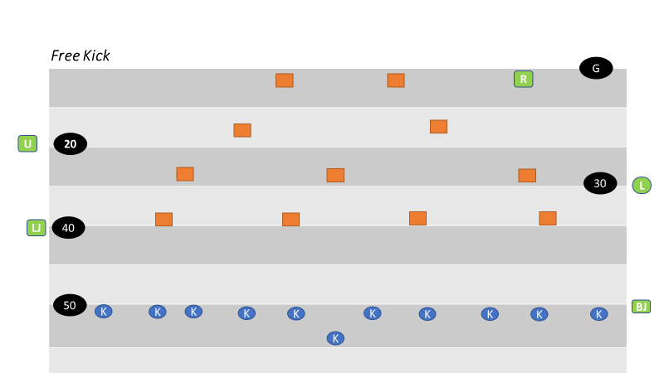

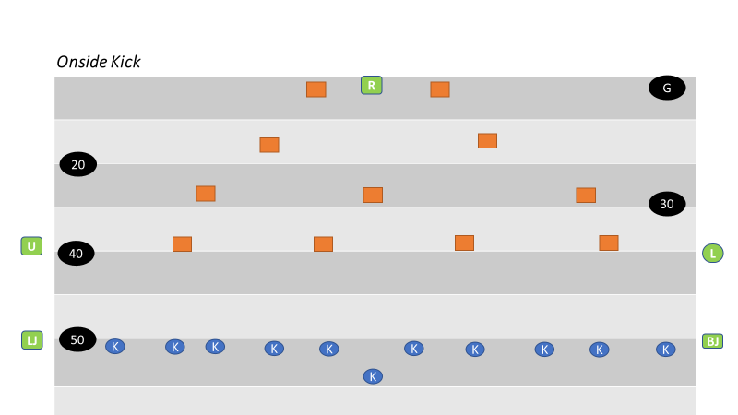

SECTION 12: KEYS

There are two basic types of keys: “Situational “and “Positional” keys

- Situational Keys
  - Situational keys are based on the down, distance, score, time remaining, offensive and defensive formations and actions of players at the snap.
  - In addition to down, distance and other fame factors, offensive and defensive formations provide hints as to what type of play an official can expect in a given situation. Most teams using the wishbone formation, for instance, are predominantly running teams. Teams using four-receiver sets and shotgun formations pass more times than not.
  - Linemen provide situational keys.
  - Pulling linemen indicate a sweep or trap block. Retreating linemen indicate a pass. Charging linemen indicate a running play. When offensive linemen provide only passive resistance, allowing defensive linemen to penetrate the neutral zone, a screen pass often follows.
- Positional Keys
  - Positional keys are predetermined by the position you are working in the game.
  - Positional keys deal more with the Back Judge and Flank Officials.
  - The Back Judge’s main positional key is the inside-most eligible receiver on the strong side of the formation. At the snap, the Back Judge first observes the tackle to see if he’s run-blocking or pass-blocking, then observes the actions of his key receiver. If that player moves into another official’s coverage area, the Back Judge shifts his attention to players who have entered his coverage area.
  - Receivers, who are closely defended, always have priority coverage.
  - In order to determine positional keys, the officials must recognize the strength of the formation (strong side vs. weak side). The strong side is the side on which there are more eligible receivers outside of the tackle.
  - When determining keys, it doesn’t matter if a player is on or off the line of scrimmage. If players are stacked, the player nearest the line of scrimmage is considered to be the widest. For example, if a flanker is stacked directly behind the tight end, the tight end is considered the widest and is the Flank Official’s key.
  - A balanced formation is one in which there are the same number of eligible receivers outside the tackles on both sides of the formation.
  - An unbalanced formation is when one side has more eligible receivers on one side than the other.
  - The Back Judge has priority in determining keys, followed by the Flanks. Officials should not key the same player as the Back Judge.
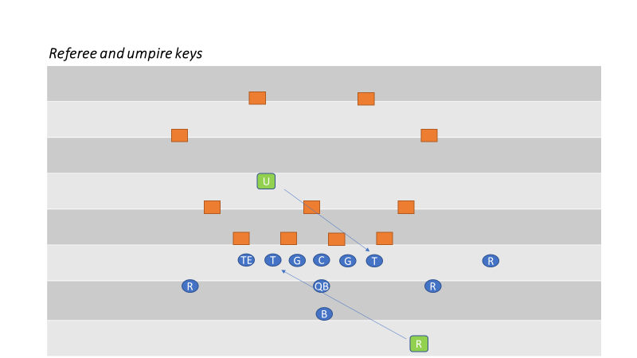

- Unbalanced Formation
  - The Back Judge keys on the inside-most receiver on the strong side. The Flank Official on the strong side keys on the widest player of the formation, normally a split end. The Flank Official on the weak side keys the end nearest his side, normally a wide out.
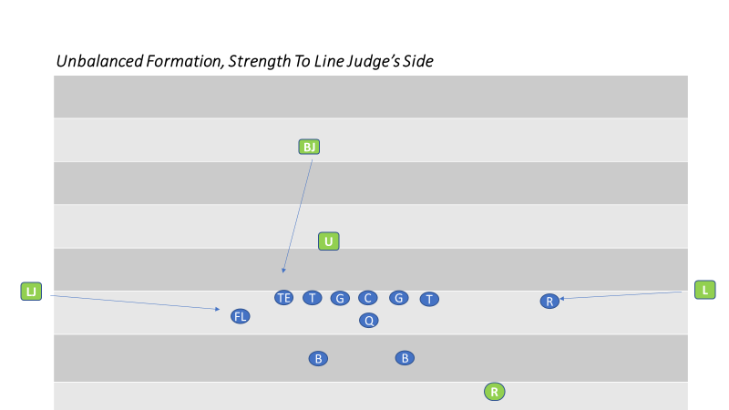

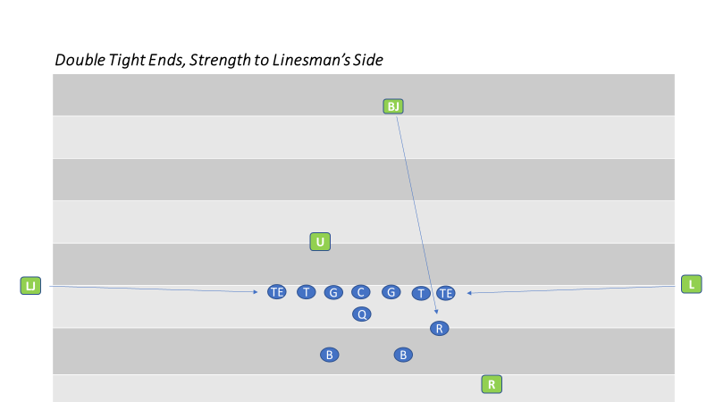

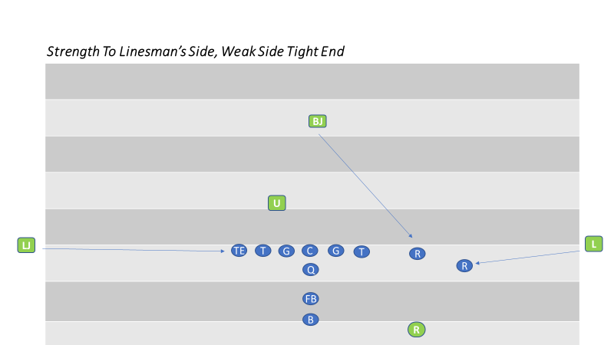

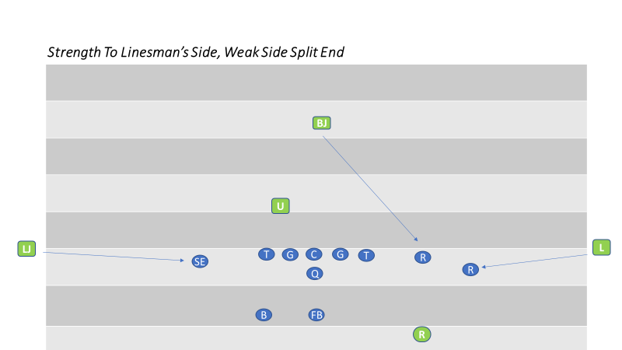

- Balanced Formation
  - In a balanced formation, strength is considered to be to the Lind Judge’s side of the field. The Back Judge keys on the inside receiver (usually a tight end). The Flank Officials key on receivers other than the Back Judge’s key and any backs who move toward them at the snap.
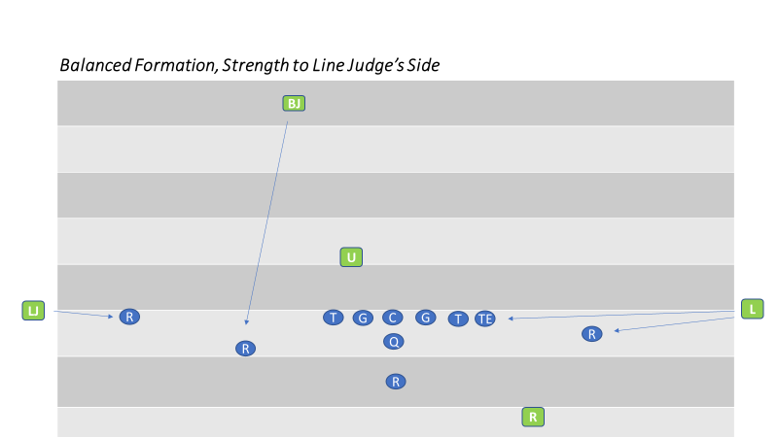

- Three-Receiver (Trips) Formation
  - The Back Judge keys on the two inside receivers and the strong side Flank Official keys on the widest receiver. The weak side Flank Official keys on the end nearest him.
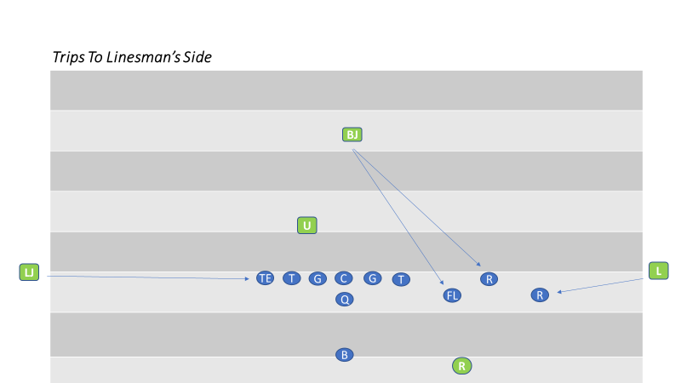
- Double Wing Formation
  - Strength is declared to the Line Judge’s side. The Back Judge keys the inside receiver on the Line Judge’s side. The Line Judge keys the widest receiver. The Linesman has both receivers on his side.
  - Flank Officials need to know that backs lined up between the tackle are the responsibility of the official whose side they come toward in route.
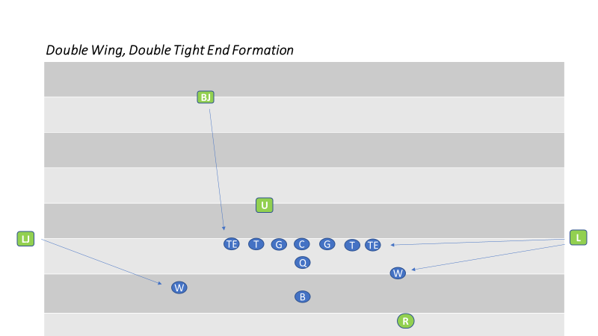

- Motion
  - An offensive player in motion can affect positional keys. It is crucial that the Back Judge and Flank Officials know where the motion man is at the snap because the strength of the formation (and therefore the keys) may change.
  - Team lines up strong to the Linesman’s side, but the Flanker on Linesman’s side goes in motion toward the Line Judge. If the motion man gets to the Line Judge’s side of the ball at the snap, the strength of the formation is now on the Line Judge’s side and the keys change. The Back Judge now has the motion man on the Line Judge’s side, the Line Judge has the widest receiver and the Linesman has the end on his side of the line. The Linesman is responsible for watching to ensure the motion man does not cut up field before the snap. Legality of motion is always the responsibility of the official away from whom the player is moving. If the player doubles back and goes in motion toward his original position, the official originally watching him continues to be responsible for determining legality of the motion.
  - If the motion man does not get to the opposite side of the formation and outside the frame of the tackle before the snap, the keys do not change because the strength of the formation has not changed.

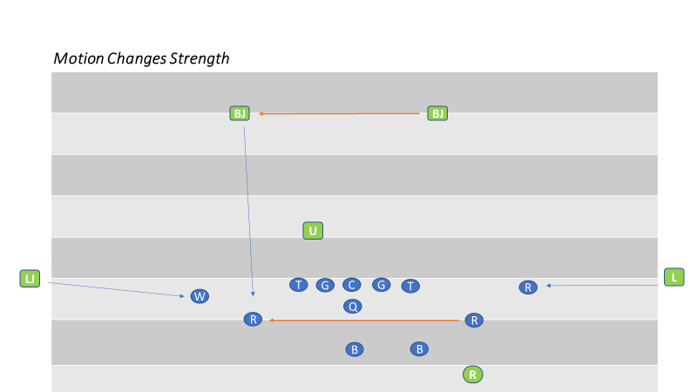

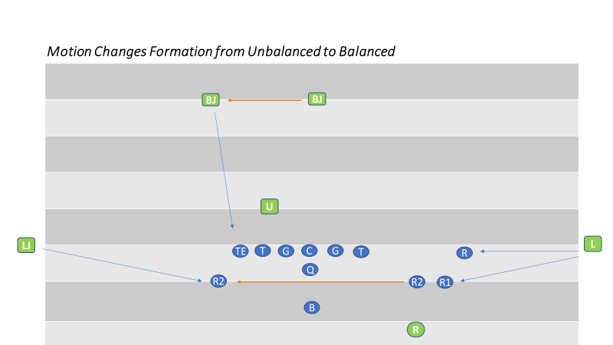

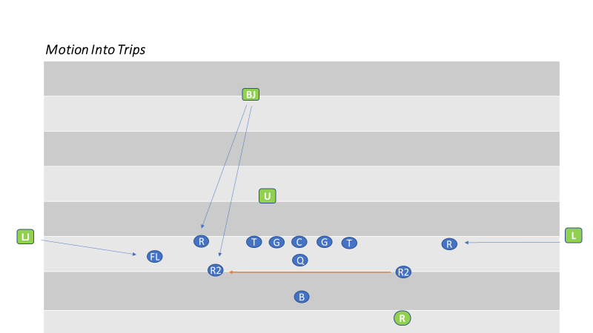

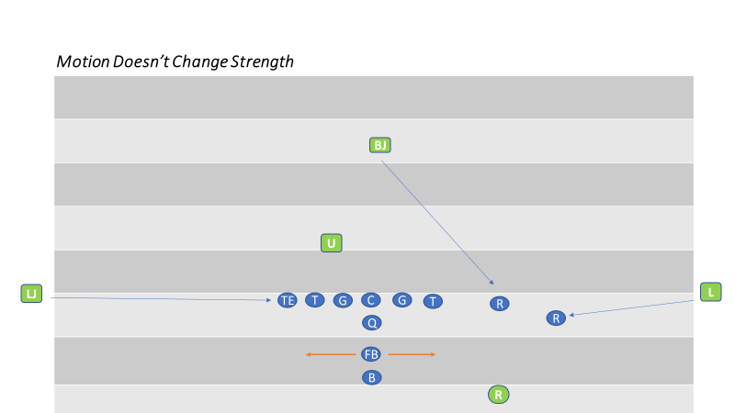

SECTION 13: PLAYS FROM SCRIMMAGE

BASIC POSITIONS

- All Officials
  - Basic positions may vary, depending upon play situations, team formations, the field and weather conditions. Always box in the play. Avoid positions that may cause scrambling to avoid interference with plays.
- Referee
  - Be in a position 12 to 14 yards deep and 12 to 14 yards wide of the original position of the ball, where you may comfortably see the ball and backs except Flankers, or a man in motion toward you. Usual position on the throwing arm side of the quarterback behind the deepest back, in position to see the snap.
  - Check the offensive formation and count the offensive players.
  - Check the back and quarterback for illegal motion, the ball at the snap, and assist the Umpire if there is movement of restricted Lineman.
- Umpire
  - Alignment is variable according to formations of both teams avoiding position that may interfere with players. Adjust distance behind the defensive line according to width of Team A’s formation and, except on goal line or try situations, be at least seven yards deep. Whenever possible coordinate your position with that of the Referee for best coverage of interior line play. Read point of attack and your interior linemen. Know the ineligibles and where a forward pass first strikes anything.
- Flank Officials
  - In the neutral zone extended and WIDE, out of bounds, off the sideline. Do not setup inside the 9-yard marks on your side. Adjust to the formation. Indicate offensive line of scrimmage by an extended foot, don’t exaggerate. Take final position astride the neutral zone. Hand signals shall be used to indicate when the Team A player closest to you, on your side, is off the line of scrimmage. If Team A has an unbalanced line, the Flank Official who has four (or more) linemen on his side may so indicate by putting his open hand to the side of his face.
  - Responsible for legality of motion man whenever he is on your side of the snapper (in any direction), until the snap. DOES NOT RELIEVE OPPOSITE OFFICIAL FROM MAKING OBVIOUS CALL!
  - Be aware of the importance of assisting the Referee in making forward progress behind the neutral zone, particularly when the goal line is involved.
- Back Judge
  - Take position slightly behind deepest defensive back, approximately 20 to 25 yards beyond the scrimmage line. Favor the open side or middle of the field. Adjust to flankers and possible receivers. Be on the side of the tight end if only one.

SECTION 14: RUNNING PLAYS

- Referee
  - Responsible for the ball and the runner and action around him to the neutral zone. If the action is not in the direction of your original position move toward or parallel to the line of scrimmage, maintaining position approximately in line with the runner’s progress. Close in on the ball when it becomes dead. If the runner is moving in toward your position, be deep enough to allow necessary clearance and then move toward or parallel to the line of scrimmage, maintaining a position approximately in line with the runner’s progress. Close in on the ball when it becomes dead and there is no threat of a foul.
  - When the runner in the side zone reaches the neutral zone, turn him over to the Line Judge or Head Linesman. They are responsible for marking the forward progress spot behind the neutral zone, and the out of bounds spot behind the neutral zone. Cooperate with the Umpire on spotting ball. Quick handoffs that result in short yardage gains will be the responsibility of the Umpire or Flank Officials with the Referee concentrating on action behind the ball. When the quarterback turns up field with the ball, assume responsibility for the “pitch man”, until there no longer a threat of a foul.
  - On plays going towards the line of scrimmage, if the runner is driven backwards after forward progress is stopped, retrieve the ball from the runner and relay it to the covering official.
- Umpire
  - Position prior to the snap is dictated by the formation. However, you must be in a position to see the snap. Under normal circumstances the Umpire should be positioned on the side opposite the tight end. The Umpire is responsible for the legality of the snap, with assistance from Referee and Flank Officials.
  - Just prior to and at the snap the Umpire will be certain that the defensive team does not use words or signals which obviously disconcert their opponents when they are preparing to put the ball in play. The Umpire should be in position to see the snap and rule on illegal movement of lineman or ball. The Umpire continues to observe his area of responsibility as long as there is a threat of action.
  - Umpire continues to observe his area of responsibility as long as there is a threat of action.
  - When play develops in his direction and a hole opens, he should move away from the Ball Carrier while maintaining lateral position. The Umpire should check for illegal use of the hands, holding, and other fouls by both offensive and defensive players in his area.
  - As the play develops between the tackles, the Umpires’ primary responsibility is to cover the action of players at the point of attack, then behind the ball and finally around the runner.
  - On short, quick runs through the line, between tackles in close formation, the Umpire generally will sound his whistle when the runner’s forward progress stops directly in front of him beyond the line of scrimmage. (This is not routine, be sure the ball is on the ground) The Line Judge and Head Linesman will indicate forward progress for Umpire to correctly spot the ball.

  - When the runner moves into the side zone, the Umpire will clean-up the area between his position and the ball. The Umpire may, if necessary, move in near the sideline when to assist with coverage of the action, in order to go where they play takes you. When the ball is in the side zone, the umpire must be in position to observe action away from the ball and around the runner from an inside out-position. When the play is over, all officials have responsibility to rule on late blocks and other illegal acts.
- Head Linesman and Line Judge
  - Initial position should be out of bounds, off the sideline. Cover the runner in your side zone beyond the line of scrimmage and out of bounds. Mark forward progress with down field foot, extended slightly toward the spot; don’t exaggerate. When marking forward progress, converge rapidly on the dead ball spot when play in your area permits. Be alert to cover forward progress spot when runner has been pushed back. Opposite side officials should assist with the forward progress spot if the covering official is not in position to rule.
  - Observe initial charge on your side. You are responsible for blockers and action on ends and linebackers on your side. Pick up the runner when he crosses the neutral zone in your area. Spot the ball on quick thrusts and close line plays. If play goes away from you, observe action behind runner and assist with action on the pitch man if he does not receive the ball. Maintain a position in relation to the runner’s progress observing the play behind the Umpire and in front of the Back Judge. Be alert for the runner returning to your area.
  - After the play is over, assist the Referee or Back Judge in getting the ball back to the Umpire.
- Back Judge
  - Cover plays from behind defensive backs. Watch for action by and on your key(s). Bracket runner between yourself and either Flank Official, depending on the side zone runner is occupying. Maintain enough depth to keep players boxed in. Cover continuing action in advance of the runner.
  - On running plays ending out of bounds, especially in team areas, move into dead ball area and assist Flank Officials and Referee with maintaining order. The presence of another official stops most dead ball fouls in the team areas. Some out of bounds runs may necessitate coming rapidly into the team area while observing all action. Go where the play takes you.
- All Officials
  - Watch for fouls by blockers leading the runner and for fouls after ball is declared dead. The use of signal #7 to indicate dead ball fouls should be used only by referee when fouls are involved.

SECTION 15: FORWARD PASSES

BASIC POSITIONS AND AREA COVERAGE

- Referee
  - When the passer retreats, remain wide and deeper than the potential passer. If the passer is not threatened, observe legality of blocks in the offensive backfield and by line keys. The Referee is solely responsible for intentional grounding and should use a bean bag to mark the spot of the pass if need to confer with other officials. Referee may consult with other officials on the positioning of eligible receivers. Remain behind the line to observe legality of the throw and action against the passer. After the passer throws the ball, continue to observe him until there is no threat of a foul. Ensure that the passer is not roughed or thrown roughly to the ground. Verbally alert the defenders when the passer has released the ball. Continue to observe the offensive and defensive players action behind the line before moving out of the area.
- Umpire
  - Check legality of numbers of interior offensive linemen at the snap. Observe action of players in, and directly behind, the neutral zone, illegal advance downfield of ineligibles, and assist with trapped and button-hook passes. When Umpire reads a forward pass play, he should step toward the line of scrimmage. This removes him as a target, and opens up his area for shallow drag-pass patterns. This position permits Umpire to observe linemen moving illegally downfield. After observing play of linemen and their contact with up blocking backs, pivot to assist on low trajectory and short passes over the center of the line. Know where ball first touches anything on forward pass. Use signal #11 when appropriate. Assist the Referee in determining legality of forward passer.
- Flank Officials
  - Assist the Umpire in checking the legality of numbers of offensive interior linemen. Check legality of positions for players with eligible numbers. After initial charge of linemen, move into position to check blocking and contact of eligible receivers and linebackers. Be ready to rule on the direction of a quick quarterback pass. The covering official, toward whom the ball is thrown, should signal, by extending one arm horizontally in the direction of the offensive backfield if the pass is ruled backward. Drift downfield cautiously for the first 5-7 yards, approximately halfway between flat zone and deepest receiver. While pass is in flight, move to the most advantageous position to judge the play. If the receiver is driven backward after the catch, the opposite Flank Official should assist in marking the forward progress spot. Always be prepared to come back to rule on play near the neutral zone in addition to sideline action. Observing the wide initial position is helpful in covering any pass. If potential passer decides to run, you must cover him beyond the neutral zone. Entire sideline is your responsibility.
  - After an incompletion, obtain a ball from the ball person and form a relay to return the ball to the official nearest the previous spot.
  - If an airborne player receives a pass near the sideline and first returns to the ground out of bounds, after giving the incomplete signal, the covering official may, with both arms, give a sweeping motion towards the out of bounds.

- Back Judge
  - Cover plays from behind deepest receivers. Initial focus on your key(s) as they leave the Line of Scrimmage. Once receivers are no longer threatened at the Line of Scrimmage, you should transition quickly into zone coverage. Bracket pass receivers between yourself and either Head Linesman or Line Judge, depending on location.
- All Officials
  - Be alert for an illegal pass, especially after a completion. Observe touching or catching by an ineligible player. Watch particularly for holding or illegally contacting eligible receivers and all contact beyond the neutral zone both before and after the pass is thrown. Observe action when opposing players contest for the pass.

SECTION 16: GOAL LINE PLAYS

- Referee
  - Position and coverage are the same as for other scrimmage plays with the forward point of advancement is usually determined by the Flank Officials. Signal score only after you are positive that all requirements are met.
- Umpire
  - Adjust your position to account for proximity to the goal line, but never directly on the goal line. Never signal score but assist the Head Linesman and Line Judge verbally or visually if necessary.
- Head Linesman and Line Judge
  - Initial position must be wide, out of bounds and off the sideline. When the ball is snapped at or inside the 5 yard line, move toward the goal line at the snap and rule on the score or an accurate forward point when you see the ball.
- Back Judge
  - Start on the end line of the snap is on or inside the 12 yard line. Assume complete responsibility of the end line coverage.
- Umpire, Head Linesman and Line Judge
  - If the balls forward progress stops short of the goal line, move in on the ball, mark and hold the dead ball spot until the ball is spotted for the next play.
- All Officials
  - Indicate the score with the touchdown signal only when in position to determine that all requirements are met with the exception of the umpire who will never signal.

Reverse Goal Line

- Referee
  - Looks to appropriate Flank Official for progress spot or safety signal.
  - 7 yards.
- Umpire
  - Continues to observe blocking.
- Head Linesman and Line Judge
  - If runner is clearly downed in end zone in coverage area, hustle in and signals safety. If runner is out of coverage area, hustle in for dead-ball officiating.
- Back Judge
  - Observes action of players away from pile.

SECTION 17: FUMBLES

SIGNALS

The closest official who actually sees the fumble, and who has recovered it, should point in the proper direction, no matter who recovers. If there is a change of possession, make sure to signal time out, “Stop the Clock!” The Referee will then signal the next down when he makes the ball ready for play.

DIGGING OUT FUMBLES

Should it become necessary to “dig out” a fumble, the official nearest the ball should dig for the ball. The next official to the area should signal to stop the clock and look to the clock to ensure it is stopped. The stop the clock signal should be relayed by the remainder of the crew.

When the digging official determines possession he should verbally relay possession information to the nearest standing official, normally the Referee, who will then signal the proper direction. If possible, the signaling official will point to the recovering player to assist the press box. Only the Referee, if he is not the signaling official, should relay the direction signal.

SECTION 18: SCRIMMAGE KICKS (PUNT PLAYS)

BASIC POSITIONS AND COVERAGE

- Referee
  - Takes position at the side of the kicker, wide enough to see the ball from the snap to the kick. Be able to see blockers and kicker at the same time. Be in position three to five yards outside the tight end and two to three yards behind the kicker, on kicking leg side. Adjust to the situation; if punter is kicking from own end zone, warn kicker if they are on outside the end line prior to the snap.
- Umpire
  - The Umpire is positioned 7 to 10 yards beyond the line of scrimmage and favoring the Line Judges’ side of the field. The Umpire slowly turns and moves downfield after the ball has crossed the line of scrimmage.
- Flanks
  - Line up the same as for runs and passes. Check offensive linemen as to whether they are on or behind the line of scrimmage, and for an unbalanced line.
- Line Judge
  - If the line of scrimmage for A is at or about the 40-45-yard line for B then the line judge will position himself at the goal line pylon. This is coffin corner mechanic.
- Back Judge
  - Take position outside and behind the deep receivers, 7 to 10 yards to the side and 3 to 5 yards behind the deepest receiver, so that you may have the best view on the catch. Adjust to play area and assume responsibility for coverage into either sideline. If necessary, retreat, and move backward at a 45-degree angle.
  - If the line of scrimmage for A is at or about the 40-45-yard line for B then the Back judge will position himself at the goal line pylon. This is the coffin corner mechanic.

AFTER THE SNAP

- Referee
  - Watch blocking and illegal action by players behind the line. Observe action of and against the kicker, using signal #11 if appropriate, and observe players while proceeding slowly downfield if the kick remains inbounds. If the flight of the kick is toward a sideline, move quickly to position in line with the flight and use arm signals to direct the official covering that sideline to out of bounds spot. When correctly aligned, drop your arm as indication that the official holds their spot until ball is spotted for the next down.
  - If the kick is caught or recovered downfield, be conscious of coverage of either sideline. Be prepared to take over the runner.
- Referee, Umpire, Line Judge and Head Linesman
  - Be alert for blocked kick. Be alert for recovery and advance.

- Umpire
  - Look down the line at the initial charge, checking blocks of offense and action by defensive players. Observe defensive linemen over center to avoid roughing or serious injury to snapper. Shift observations to contact between defensive players. After the first wave of players advance down field, move toward the return area. Observe the center area for illegal action by players of either team.
- Head Linesman and Line Judge
  - If the kick is short or partially blocked, know if it crossed the neutral zone.
- Head Linesman
  - Primary responsibility to know if kicked ball crosses neutral zone.
  - After initial line charge, observe offensive backs for holding, and defensive holding in the line area. When the kick has clearly crossed and will not threaten the neutral zone, release and move downfield. If the kick is short to your side, observe first touching, legal or illegal, kick catch interference, valid or invalid signal for fair catch. Maintain position to cover in front of the runner after catch or recovery of the kick, maintain coverage until the runner cuts toward the opposite side or, if on your side, is picked up by you. You have responsibility for the entire sideline on your side.
- Line Judge
  - After initial line charge, observe offensive backs for holding, and defensive holding in the line area. Stay on line until it is apparent it is a kick, immediately move downfield in an easy run. If the kick is short to your side, observe first touching, legal or illegal, kick catch interference, or valid or invalid signal for fair catch.
  - Maintain position to cover in front of the runner after catch or recovery of the kick, maintain coverage until the runner cuts toward the opposite side or, if on your side, is picked up by you. You have responsibility for the entire sideline on your side.
- Flanks
  - During the kick, observe action on and by the ‘flyer’ (Team A players charging towards the receiver) and receivers positioned close to the line of scrimmage. When the ball is not in your area, take a position to observe action in your area ahead of the runner.

AFTER THE KICK

- Back Judge
  - If kick is short to either sideline, the sideline official will assume responsibility for the ball. Observe action in front of the ball. On all other kicks cover the receiver, taking a position ahead of the receiver if possible. Observe first touching, interference, and fair catch situations. Be prepared to rule on a muff or fumble. Cover kicks on ground or in air which go 25 yards or more. If in doubt as to spot of out of bounds kick in the air, raise hand and Referee will assist. If there is any question regarding covering official, communicate verbally.
  - Back Judge will be primarily responsible for ruling on fair catch signal in his area. Flanks observe other action surrounding the ball. If player signaling fair catch does not touch the ball, Flanks must observe legality of his actions until the ball becomes dead. Be ready to rule on kick in end zone. Be alert for batting. Use a bean bag to mark the spot where kick ends.
- Flanks
  - If kick goes to side opposite you, drift downfield while kick is in flight, observing all action and be alert for a sudden cut toward your side and possible exchange in coverage of the runner. When you do not have the ball, take a position to observe action in your area ahead of the runner.
  - Mark and hold out of bounds spot of rolling kick on your side. Be alert to cover and accept Referee’s signal in spotting out of bounds kick in flight.
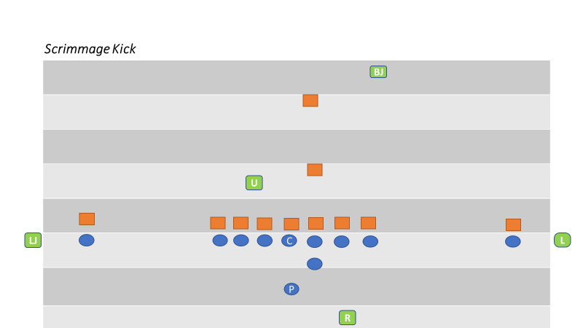

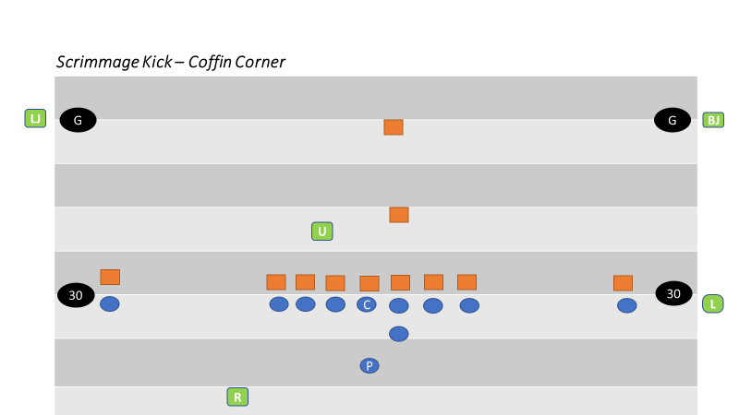
SECTION 19: TRY AND FIELD GOAL PLAYS

BASIC POSITIONS AND COVERAGE

- Referee
  - On a try or field goal, Referee’s position is a yard or so to the rear and several yards to the side of the potential kicker, facing the holder where you can see the ball when spotted for the kick. Covers as usual if a run or pass. Assist in sideline coverage if run develops to Flanks vacated side. Signal score after being positive that requirements are met. Rule on roughing or running into the kicker and/or holder.
  - When it is obvious a kick will take place and a potential holder and potential kicker are not seven or more yards behind the neutral zone, the Referee will place an open hand on his chest, indicating to the U that Team A is not in a legal scrimmage kick formation.
- Umpire
  - Adjust to favor vacated Flanks side. Adjust depth based on length of kick. Look down the line at the initial charge, checking blocks of offense and action by defensive players. Observe defensive linemen over center to avoid roughing and serious injury to snapper. Shift observations to contact between offensive and defensive players. Assist in goal line coverage if run develops to flanks vacated side.
- Flank Official Facing the Referee
  - Responsible for legality of the snap and entire line of scrimmage. Quickly move to goal line if a run develops. After the kick, move onto the field to observe dead ball action by players on the line of scrimmage. If the kick is short or partially blocked, must know if it crossed the neutral zone.
- Flank Official on the Back Side of the Referee
  - Responsible for your upright goal post. If run develops to your vacated side, quickly move along back line to back pylon to rule on the sideline. Next move is toward goal line to assist. If run situations develop to the other side, opposite Flank has primary sideline responsibility with Referee’s assistance. If attempt is short and ball remains alive, officiate as a scrimmage kick on field goals only.
  - If the kicking team’s initial formation is the “Swinging Gate,” remain on the line of scrimmage until the team shifts into scrimmage kick formation with an obvious kicker and holder. If the kicking team originally lines p in scrimmage kick formation and then shifts to another formation, move to the end line corner of the end zone during the shift and then down the sideline toward your normal scrimmage play formation. Be ready to rule on the goal line.
- Back Judge
  - Responsible for your upright goal post and rule if ball hits or goes over, the cross bar on kick. If run develops, move to goal line to assist in ruling. If attempt is short and ball remains alive, officiate as a scrimmage kick. Sound whistle when ball becomes dead on attempted field goals and kick tries.
- Back Judge and Flank Under the Goal Post
  - When the field goal or try attempt narrowly passes outside an upright, the official nearer the ball may give a sweeping motion with both arms away from the upright.
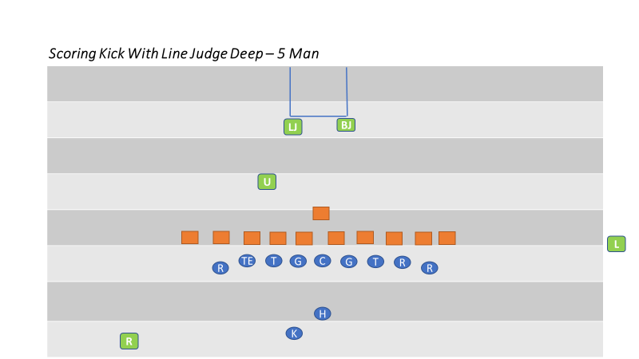

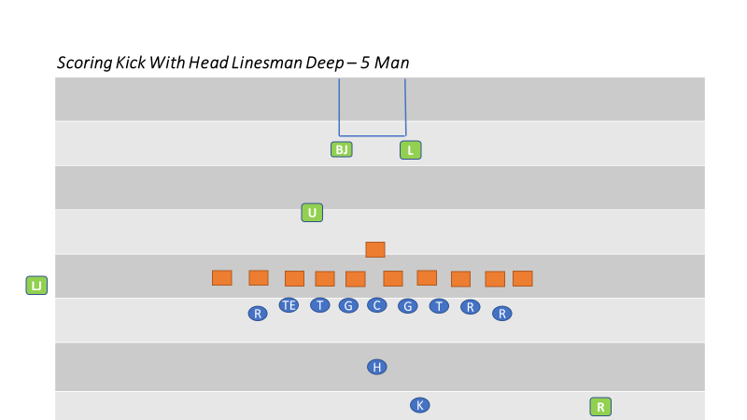

SECTION 20: TIME OUTS

PROCEDURES

- Referee
  - Indicate a full length charged time out by facing the press box. Give time out signal then extend one arm in pointing fashion, horizontally, in direction of requesting team.
  - Check with Umpire as to the number of time outs charged to each team and the playing time remaining in the period. Notify the head coach when his team time outs are exhausted.
- Flanks
  - Notify a coach from team on your sideline as to the number of time outs remaining for each team and of the time remaining in the period.
- All Officials
  - When relaying the number of time outs, relay the number that the teams have remaining.
- Referee
  - Upon Back Judges’ signal that the time out interval has expired, or when both teams indicate readiness to resume before that time, direct teams to prepare to resume play. Go to position, get ready signals from each captain and declare the ball ready for play within five seconds.
- All Official
  - Record time left on the clock and number of requesting player when charged team timeout is requested. Do not huddle unless necessary. Ensure that both teams are conducting a legal time out depending on their location. (Between the nine-yard marks or the hash marks)
- Flanks
  - Take a position halfway between your team and its team area. Direct teams to prepare to resume play upon signal from Back Judge.
  - Check number of players in your team’s huddle. Repeat this check after taking position for the next down. Flanks are responsible for teams on their side.
- Umpire
  - Quickly take position over the ball. Remain over the ball until released by the Referee.
- Back Judge
  - Time the one-minute time-out interval. When 20 seconds remain in the interval, sound your whistle three times, short but sharp. Move to your position and give a visual signal to the Referee when the interval expires. Be alert to assist the Referee if needed.
- Officials Time Out
  - Signal time out, then indicate Officials’ time out by tapping chest with hands.
  - Any Official may stop the clock for a coach’s conference. If the coach is not correct on their reason for requesting a coach’s conference, the coach’s team will be charged with a time out. After the time out has been charge, the procedure for a team time out will be carried out.
  - Signal time out when Team A is awarded a first down.
  - Declare ball ready for play as soon as needed when time out has ended.

- All Officials
  - Signal time out and carry out usual duties.
  - When either team is in possession of the ball in advance of the line to gain, covering official indicates time out.
  - If game is disrupted for any reason, record down, team in possession, position of the ball and time remaining in the game.
- Injury Time Outs
  - Same as team time out, however permit as much time as is necessary. SAFETY OF INJURED PLAYERS IS MOST IMPORTANT. Use signal #3, followed with tapping hands on chest.
  - Do not allow players to assist teammates but direct that they wait for trained staff.
  - The Referee may permit water attendants to tend to their teams on the field during extended injury time outs.
  - The Referee may also direct both teams to head to their respective sidelines if it appears the injury time out will be lengthy. Instruct the 11 players to stay on the field while coaches remain off the field.

SECTION 21: MEASUREMENTS

PROCEDURE

- All Officials
  - When establishing forward progress or the end of the run, be sure there is no need for measurement before announcing the down. If close, announce the down and be alert for either captain’s request for measurement. If doubtful, call for measurement without captain’s request. In usual circumstances, the Line Judge will assist Referee with determining obvious first downs by stopping the clock. When a play ends close to the down marker, the Line Judge can assist the Referee by indicating “close”. The Referee can then move to the spot to determine if a measurement is needed or if a first down will be awarded.
- Back Judge
  - Will ensure the ball is not moved after being spotted for measurement. If holding the ball is necessary, assume a position parallel to the ball’s axis and in advance of the line to gain, allowing room for chains, etc.
  - Clear the area of officials and players for press box view.
- Referee
  - When the ball becomes dead in a side zone or out of bounds and measurement should be at the dead ball spot, have covering official place the ball at the proper spot. Indicate to the Head Linesman and to the press box that a measurement is needed.
- Head Linesman
  - Instruct the box operator to place the box at the position of the front stake, maintaining the previous down. Grasp the line-to-gain indicator and clip at back edge of back-yard line (don’t just grasp clip since clip could detach).
  - Bring the line-to-gain indicator behind ball and place clipped part of indicator at back edge of back-yard line.
  - Hold firmly and call “ready” to Umpire to stretch the chain tight.
- Line Judge
  - Go to yard line nearest rear stake. Mark a spot perpendicular to the ball to aide.
  - Assist the Head Linesman in positioning the chain for an accurate measurement.
- Umpire
  - Take forward rod. Check for kinks in chain and be sure that chain is taut. Wait until Head Linesman calls “ready” then carefully tighten the chain only once. Don’t pull or jerk it. Have the rod perpendicular to the ground at the side of the ball until Referee announces his ruling, and then return rod to the chain crew.
- All Officials
  - If short of the line-to-gain, use the forward point established on the chain when spotting the ball at the inbounds line. If alternate game ball is available following the measurement, leave the ball in the side zone until an alternate ball is placed at the corresponding inbounds spot.

- Head Linesman
  - If the end of the play was short of the line-to-gain, retain firm grasp of the chain and personally reset the chain at its original spot on the sideline. Check the point marked by your down box person and changes the down box indicator to the next down.
- Referee and Umpire
  - Umpire remains over the ball and the Referee announces down and distance. Get ready signals from the captains while Head Linesman is resetting chain. When Head Linesman is ready, declare the ball ready for play.

SECTION 22: CALLING FOULS AND ENFORCEMENT

PROCEDURE

- All Officials
  - The calling official will drop or throw marker at proper spot, mentally marking the yard line. If ball is alive, withhold whistle until the ball becomes dead; then continue to sound whistle with short loud bursts, until you are certain other officials are aware a foul has been called. The official should then communicate the information to the Referee. For pre-snap fouls, visual signals are acceptable.
  - Know status of ball if it is in play. Make mental note as to whether the clock should be started on the ready or on the snap.
  - Do not place a hand on or point to the offending player. Nearest official will notify, by position or number, a coach of non-disqualifying fouls by his team. On encroachment, false start fouls, etc., if more than one marker is down, calling officials should consult with each other before reporting the foul. If Umpire is involved, he should report the foul to the Referee. Drop your flag when giving a sideline warning. Notify the head coach then go to the Referee and report the violation. Each official should record Sideline Warnings and the Referee will signal.
  - After calling foul, get Referee’s attention as soon as ball is dead, sound whistle and give verbal description. It is your duty to make sure another official is covering the spot of foul if foul is spot foul; then go to Referee and report the foul fully as follows:
    - Foul called. Who fouled? Offense or Defense, Return or kicking team. What the foul was? Where did the foul occur? Behind or beyond LOS. When did the foul Occur? Live or dead ball?
      - Offending team, including jersey color and A/B, offense/defense or kicking team/receiving team.
      - Offending player’s number or position.
      - Spot of foul, previous spot, end of run or end of kick.
      - Status of ball when foul occurred.
- Head Linesman, Line Judge and Back Judge
  - Foul called by another official:
    - If ball is not at dead ball spot, assist in getting it there.
    - Cover and hold dead ball spot and mark end of run. Leave ball on ground.
    - If the foul is a spot foul, cover and hold spot of foul.
    - Observe players and assist where needed.
  - Covering Spot of Foul:
    - Hold spot as long as necessary. Ascertain foul and offending team. When Umpire starts to enforce the penalty, pick up marker of official who called foul.
    - If enforcement spot is different from spot of foul, see that it is covered by an official.
    - If enforcement is from spot of foul, Linesman shall hold spot during enforcement. Umpire will release him/her.

    - When fouls are committed that require enforcement at the spot of the next free kick, Referee will give the preliminary signal and point to the next free kick spot. Back Judge will repeat the signal following enforcement from the succeeding spot.
- Referee
  - When foul or fouls are reported to the Referee, they will immediately give preliminary signal or signals to press box side before explaining options to captains. Notify both captains if loss of down is part of the penalty. Give dead ball signal before giving he signal for a dead ball foul. For pre-snap fouls, preliminary and dead ball signals are not required.
  - If a choice is obvious, announce it and proceed with enforcement or declination. If captain objects, explain alternatives and conform to his choice. If choice is not obvious, explain foul or fouls and the options, state options briefly, but correctly, clearly and courteously. Notify captain of offending team of foul called and number and position of offending player (if possible).
- Line Judge
  - Hold enforcement spot until penalty is completed and confirm with Umpire that the enforcement is correct before releasing the spot. (Exception: Penalties assessed on kickoff).
- Referee
  - When penalty is to be enforced, confirm with Umpire as to point of enforcement and yardage to be marked off.
- Umpire
  - Take a position near Referee when he explains options to a captain. If penalty is to be enforced, follow Referee’s instructions in marking off the penalty. Umpire will carry ball and place in position when penalty is enforced. If “tick” marks are available, use them to assist in getting the correct yardage. Otherwise, mark off the yardage as instructed. Communicate enforcement to the Head Linesman, who will mark off penalty yardage with the Umpire.
- Head Linesman
  - When Umpire starts to mark off penalty, be on or near the sideline and move to the succeeding spot. Check visually with Umpire; if enforcement is correct, direct Chain Crew to move down indicator and direct moving of chains if appropriate.
- Referee
  - While Umpire is marking off penalty, take position in clear where you can be seen. Give signal to press box side of the field only. If equipped with a microphone, announce the number of the player committing the foul.
  - If penalty is accepted, signal foul and extend one arm in pointing fashion, horizontally in direction of offending team. If penalty is declined, signal foul, extend one arm in pointing fashion, horizontally, in direction of offending team and then give the penalty declined signal. (#10)
  - If penalties offset, signal one foul, extend one arm, in pointing fashion, horizontally in direction of offending team, repeat this procedure for foul by other team, then give penalty declined signal.
  - While facing press box, indicate the number of the next down.
  - When fouls are committed that require enforcement at the next free kick, the Referee will give the preliminary signal and point to the next free kick.
- Umpire
  - Cover the ball after completing penalty and Referee is in process of giving signal for fouls.
- Referee
  - Declare ball ready for play. Start clock if appropriate.
- All Officials
  - Official calling foul is primarily responsible to see that Referee and Umpire assess penalty properly in all aspects.

SECTION 23: END OF A PERIOD

PROCEDURES

- All Officials
  - Near the end of a period, all officials should be aware of the time remaining before the start of each play.
- Referee and Umpire
  - Referee and Umpire keep each other informed of remaining playing time. Indicate by an inconspicuous signal whether there is ample or scant time for next snap. Advise Referee at the end of the down if time expired while the ball was in play.
  - When time expires. Sound whistle only if ball is dead. The termination of a period is then indicated by the Referee holding a ball over his head with one hand. The Referee is primarily responsible for determining the end of any period.
  - At end of first and third periods, see that ball is not disturbed until exact position for transfer has been determined. Turn the ball over to the Back Judge at close of second period.

SECTION 24: ONE-MINUTE INTERMISSIONS

PROCEDURES

- All Officials
  - Observe players as they move to the other end of the field.
- Back Judge and Line Judge
  - Move downfield assuming responsibility of respective teams.
- Back Judge
  - Time the one-minute intermission between periods and the one-minute intermission after a safety, try or successful field goal. When 20 seconds remain in the intermission, sound your whistle three times, short but sharp. Move to your position and give a visual signal to the Referee when the intermission expires.
- Referee
  - Record and announce yard line on which forward point of the ball rests and the down and distance loudly and clearly enough for other officials to hear.
  - Carefully measure distance from nearest marked yard line to forward point of the ball. Distance from the inbounds line may be estimated.
  - Check with the Head Linesman and Umpire on location, down and distance, and proceed to corresponding yard line beyond the 50-yard line and have Umpire spot the ball. Do not resume play until one minute has elapsed.
- Umpire, Head Linesman, Line Judge and Back Judge
  - Record yard line, down and distance and check both before and after changing position of the ball.
- Head Linesman
  - Determine the yard line which intersects the chain between the rods. Record the down, distance and yard line upon which the ball rests. Grasp the chain at the back edge of the marked yard line, reverse the chain and the chain crew holding the rods, then move to the corresponding yardline at the opposite half of the field. Hold the point on the chain at the intersection of that line with the sideline while the chain crew tightens the chain.
- All Officials
  - During the intermission between periods, after other prescribed duties are completed, take positions to observe the teams, but away from the team areas. Upon the Back Judge’s 20-seconds remaining, move to positions for the succeeding play.
- Back Judge
  - When the succeeding play will be a free kick, upon 20-seconds remaining, deliver the ball to the kicker between the inbounds lines, and quickly return to the sideline. Be on the sideline and ready when the intermission expires.
- Referee
  - Upon the Back Judge’s visual signal that the intermission has expired, ensure both teams are ready to play, then immediately declare the ball ready for play.

SECTION 25: HALFTIME INTERMISSION

END OF SECOND PERIOD

- Back Judge
  - From the end zone give the start the clock signal when field is clear of officials and players.
  - Keep other officials informed as to time remaining in intermission. Make sure crew arrives on the field to start second half on time, at least 5 minutes before kickoff.

PRIOR TO KICKOFF

- Line Judge or Head Linesman
  - Check with head coach on your sideline and secure the second half option.
  - Work to keep the teams separated if field exit is at same location for each team.
- Referee and Umpire
  - Check with other officials regarding second half choices.
- Back Judge and Line Judge
  - Bring your team to the team area three minutes before kickoff.
- Head Linesman
  - Make certain your chain crew is ready and send them to the receiving team’s 20-yard line. Remind them to stay behind the restraining line during the kickoff.
- All Officials
  - Arrive at your kickoff position no later than one minute prior to kickoff.

SECTION 26: OVERTIME PROCEDURE (RESOLVING TIED GAMES)

END OF REGULATION PLAY
- Referee
  - Direct the teams to their respective team areas. Announce or otherwise notify press box that: “Regulation play has ended with a tie score and there will be a three-minute intermission followed by an extra period of play.”
- All Officials
  - Gather at the center of the field and review extra period rules and procedures. Overtime procedures should also be reviewed in the pre-game conference or during halftime if the game is close and there is a chance of the game ending tied. After the three-minute intermission, break to positions for coin toss.
- Back Judge
  - Ensure field clock is turned off or displays 00:00. Ensure play clock is operational.
- Head Linesman and Line judge
  - Go to your sideline and remind the head coach of extra period rules, particularly coin toss and option procedures, any penalties that might carry over into overtime, and having only 1 time-out per overtime period.
COIN TOSS
All Officials
  - After the three-minute following the end of regulation play, conduct coin toss. Assume same duties as for coin toss prior to start of game (see Section 5), except no introductions.
- Referee
  - Remind captains that the winner of the toss may not defer choice. Conduct toss, obtain choices, and move captains with their backs to their respective goal lines. Place hand on shoulder of captain (nearest press box) of team winning toss. Stand adjacent to team (to press box side) that will be on offense first and give signal 8 (first down). Simultaneously, announce choices if equipped with field microphone.
- All Officials
  - Immediately move to scrimmage positions and begin play without delay after coin toss.

ADDITIONAL EXTRA PERIOD

- Referee and Umpire
  - After a two-minute intermission the Referee and Umpire move directly to the center of the field and call for captains from both teams. Referee obtains option from captain of team that had second choice in previous extra period (only 1 coin toss for overtime), then option from opposing captain. Referee then indicates choices to press box as noted above.
- Head Linesman, Line Judge, and Back Judge
  - Perform regular coin toss duties. Immediately move to scrimmage positions and begin play without delay after coin toss.

SECTION 27: CFOA PHILOSOPHIES

The following philosophies have been adopted for CFOA games.

- Ball Spotting
  - The ball can be placed on a yard line to begin a next series after a change of possession. For example, if a punt return ends between the 33- and 34-yard lines, move the ball forward to the 34-yard line.
- Line Of Scrimmage
  - Officials will work to keep offensive linemen legal and will call only when obvious or where repeated warnings are ignored. Don’t wait until the fourth quarter to enforce rule.
  - Don’t be technical on an offensive player who is a wide receiver or slot back in determining if he is off the line of scrimmage. When in question, it is NOT a foul.
  - Wide receivers or slot backs lined up outside a tight end will be ruled on the line of scrimmage and covering the tight end if there is no stagger between their alignments. If in question, he is not covered up.
  - Formations during the execution of a trick or unusual play have the highest degree of scrutiny and should be completely legal.
- Bean Bags
  - FUMBLES: Officials shall drop the bean bag only when they see the ball fumbled, not when they see the ball loose.
  - PUNTS: Officials shall drop the bean at the spot the kick ends or the spot of illegal touching.
  - Be accurate. You are marking a potential enforcement spot.
  - Do not drop your bean bag after an interception, except when inside the 5-yard line.
- Defensive Pass Interference
  - We must assume that both the offensive and defensive players have an equal opportunity to catch a forward or backward pass.
  - Actions that constitute defensive pass interference include but are not limited to the following five categories:
    - Early contact by a defender who is not playing the ball is defensive pass interference provided the other requirements for DP have been met, (make sure the receiver is not a potential blocker) regardless of how deep the pass is to the receiver.
    - Playing through the back of a receiver in an attempt to make a play on the ball.
    - Grabbing and restricting a receiver’s arm(s) or body in such a manner that restricts his opportunity to catch a pass.
    - Extending an arm across the body (arm bar) of a receiver thus restricting his ability to catch a pass, regardless of the fact of whether or not the defender is looking for the ball. Cutting off or riding the receiver out of the path to the ball by making contact with him without playing the ball.
    - Hooking and restricting a receiver in an attempt to get to the ball in such a manner that is causing the receiver’s body to turn prior to the ball arriving.

- Not Defensive Pass Interference
  - Actions that do not constitute defensive pass interference include but are not limited to:
    - When there are tangled feet and both players are looking back at the ball or neither player is looking back at the ball.
    - When either player is making a legitimate play on the ball or there is shoulder to shoulder contact-players coming from different angles.
    - When the contact is so close to the touching of a pass that we refer to it as bang-bang pass interference it will not be called.
    - When a defender places a hand on a receiver’s body but does not initiate a turn or twist, nor a pull or push.
- Offensive Pass Interference
  - Actions that constitute offensive pass interference include but are not limited to the following two categories:
    - Initiating contact with a defender by shoving or pushing off, thus creating separation in an attempt to catch a pass.
    - Driving through a defender who has established a position on the field.
- Not Offensive Pass Interference
  - Actions that do not constitute offensive pass interference include but are not limited to:
    - A screen pass where the ball is overthrown behind the line of scrimmage but subsequently lands beyond the line of scrimmage and linemen are blocking downfield unless such blocking prevents a defensive player from catching the ball.
    - A pick play if the defensive player is blocking the offensive player when the pick occurs.
    - After the ball has been touched by B beyond the neutral zone or during any play in which B touches the ball in or behind the neutral zone. Actually, after any forward pass has been touched by either team, the conditions for Pass Interference expire.
- Other Passing Situations
  - When in question on action against the passer, it is roughing the passer if the defender’s intent is to punish.
  - If an interception is near the goal line (inside the one-yard line) and there is a question as to whether possession is gained in the field of play or end zone, make the play a touchback.
- Backward Pass
  - When in question, the pass is forward, not backyard.
  - When the QB’s hand starts forward with the ball, rule the pass forward even if he is contacted and the ball goes backward.
- Catch
  - If the process of the catch includes going to the ground, the receiver must maintain possession of the ball when he contacts the ground to be awarded a catch. The ground can cause an incompletion.
  - These requirements are the same for interceptions and fumble recoveries.
  - There is a difference in the ball moving within the receivers control and moving from a loss of control.
  - If the receiver is contacted simultaneously with or immediately after he controls the ball with one foot down and loses possession, rule the pass incomplete.
  - A play that would be ruled a catch/fumble in the field of play would be ruled a catch/TD in the end zone.
- Blocking
  - Takedowns at the point of attack, those in the open field, or within the tackle box, affecting the result of the play should be called.
  - If there is a potential offensive holding but the action occurs clearly away from the point of attach and has no (Or could have no) effect on the play, offensive holding should not be called.
  - If there is a potential for defensive holding but the action occurs clearly away from the point of attach and has no (or could have no) effect on the play, defensive holding should not be called.
  - For blocks in the back, if one hand is on the number and the other hand is on the side and the initial force is on the number, it is a block in the back. The force of the block could be slight and still a foul if the contact propels the player past the runner.
  - A grab of the receiver’s jersey that restricts the receiver and takes away his feet should be defensive holding I other criteria are met and could also be defensive pass interference.
  - Holding can be called even if the quarterback is subsequently sacked as it may be the other half of an offset foul.
  - Illegal block in the back can be called on fair catches only if the point of attack is involved or personal foul.
  - Rarely should you have a hold on a double team block unless there is a takedown or the defender breaks the double team and is pulled back.
  - When in question, if an illegal block occurs in the end zone or field of play, it occurs in the field of play.
- Free Blocking Zone
  - Blocking below the Waist is permitted in the Free Blocking Zone when:
    - All players involved in the blocking are on the line of scrimmage and in the zone at the snap.
    - The contact is in the zone.
    - The ball has not left the zone.
  - While in a shotgun formation, an offensive lineman may legally block below the waist if the offensive player (who is lined up in the Free Blocking Zone) is in a 3 or 4 point stance, and the contact is immediate and with a defensive opponent, who is lined up in the Free Blocking Zone, on the line, and head up over the offensive lineman. It will be an illegal block below the waist if the offensive lineman is in a 2-point stance, or if there is any hesitation, or if the block is not against a head up defender, as the ball will be considered to have left the zone prior to the contact below the waist.
  - Head up is defined as having both shoulders within the frame of the opponent’s body.

- Kicking
  - The kicker’s restraining line for onside and short pooch kickoffs should be officiated as a plane and any player, other than the kicker or holder, breaking the plane before the ball is kicked should be called encroachment.
  - For deep kickoffs, the foot should be on the ground and beyond the line to be called.
  - When in doubt as it relates to the receiver’s goal line, it is a touchback vs. allowing the runner to return the kick.
- Plays At The Sideline
  - If legal contact occurs before the runner has a foot down out of bounds, consider it a legal hit.
  - If the whistle has blown and a runner continuing to advance down the sideline has eased up, contact by the opponent against the runner is a foul.
- When In Doubt
  - The runner fumbled the ball and was not down.
  - The pass is incomplete vs. the ball caught and then fumbled.
  - If legal contact occurs before the runner has a foot down out of bounds, it’s a legal hit.
  - Runner continuing down sideline: If whistle has blown and player has eased up, it is a foul. Be alert and be sure any action is not part of the initial play before calling a foul.
  - A non-airborne runner crossing the goal line inside the pylon with the ball crossing the goal line extended is a touchdown.
  - When in question, the runner did not step out of bounds.
- End Of Game
  - If an offensive team goes into a victory formation, officials should use common sense officiating and make every attempt to not call fouls that have no bearing on the outcome of the game.
  - Personal Fouls and Player Safety Fouls should always be called regardless of time and score.
  - If the Referee stops play for any reason, the game is suspended and not over.
  - The official’s jurisdiction ends when the officials leave the playing field.
- Miscellaneous
  - When issuing a sideline warning, throw the flag. Make the call at the end of a down without causing an interruption but be sure the head coach has had a prior verbal warning.
  - Five-yard facemask fouls are rare, but if it is a “grasp and then let go,” it can be called. When in question it is a 15-yard foul.
  - The ball can be placed on a yard line to begin the next possession. At all other times, the ball is placed where it is. (Exception: If the change of possession occurs on a fourth-down running or passing play, the ball will be left at the dead-ball spot to begin the next series.)

  - 5/5 axiom: In order to adjust the game clock when it has been running. There must be more than a five-second differential if there is more than five minutes remaining in either half. Any time loss due to the clock being started erroneously, such as when a dead ball foul is called, the clock must be adjusted.
SECTION 28
4 PERSON MECHANICS SUPPLEMENT MANUAL

The 5-Person Mechanics Manual contains the mechanics and philosophies for officiating football in CFOA and provides the foundational information necessary to officiate a 4-Person game. The mechanics contained in this supplement are intended to assist with the transition from 5-Person mechanics to 4-Person mechanics without a significant amount of change. Officials must read and understand the 5-Person Mechanics Manual prior to utilizing this supplemental information.

NOTABLE DIFFERENCES BETWEEN THE 5-PERSON AND 4-PERSON MECHANICS:

1. Referee will time and communicate the 40/25-second play clock to the quarterback and coach
2. Wings will count Team B players and the Referee & Umpire will count Team A players
3. Pregame communication with clock operator in press box is done by the Line Judge
4. Line Judge will hold the ball during a measurement.
5. Keys
6. Positioning and Coverage of Free Kicks, Scrimmage Kicks and Scoring Kicks
7. Scrimmage Play Coverage

KEYS

- BALANCED FORMATION
  - In a balanced formation, there are two receivers outside of the tackles on either side of the formation. The wing officials’ main key is the widest receiver; the flankers are secondary keys.
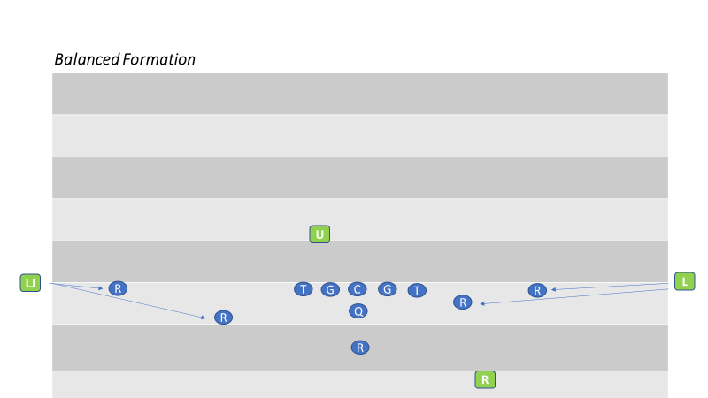
- TRIPS FORMATION
  - In a trips formation, the wing official on the strong side keys on the widest receiver on the end of the line and the two flankers are secondary keys. The other wing official keys on the tight end, the only receiver on the line on his side of the formation.
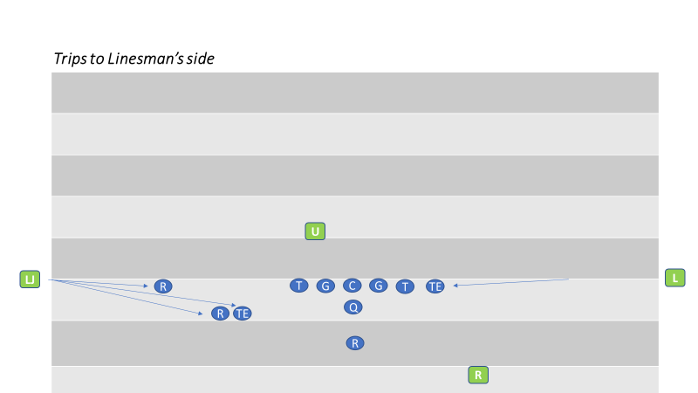

- MOTION CHANGES FORMATION FROM UNBALANCED TO BALANCED
  - Strength was to the Line Judge’s side, but motion changed the strength of the formation to the Linesman’s side. However, the Line Judge observes the action of the motion man. Legality of motion is always the responsibility of the official away from whom the player is moving. The split end is the Line Judge’s key. The flanker and the split end are the linesman’s keys
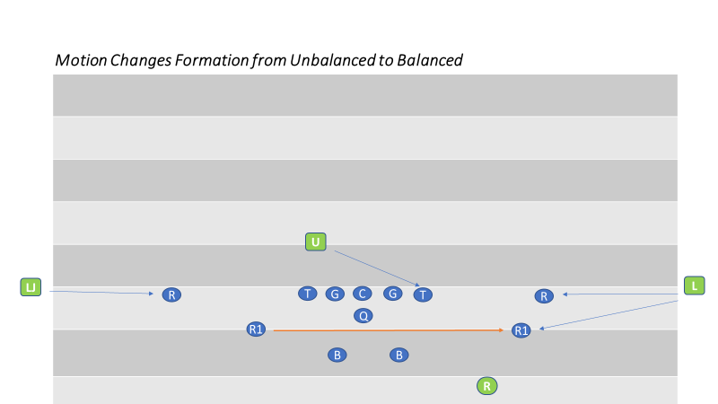

- REFEREE AND UMPIRE KEYS
  - Regardless of the formation, the Referee and Umpire key on the opposite-side tackle. It the quarterback is right handed, the Referee keys on the left tackle and the Umpire keys on the right tackle, guards and center.

POSITIONING AND COVERAGE

- FREE KICK
  - Referee
    - Starting position is near the top of the numbers near team R’s five or 10 yard line on the Head Linesman side of the field. He counts Team R players and confirms his count with the Umpire. Once he sees a ready signal from each official, the Referee blows his whistle and gives the ready-for-play signal. Because the goal line is solely the Referee’s responsibility, he must be prepared to cover the goal line to rule on momentum. Adjustments in starting position may be necessary based on kicker’s leg strength.
  - Umpire
    - Starting position is on the sideline at R’s 20 yard line. The Umpire counts the receivers and signals the Referee by raising an arm overhead when he is ready for the kickoff.

  - Linesman and Line Judge
    - The Linesman is on team K’s restraining line; the Line judge on team R’s restraining line. They each count Team K players. The Linesman should not give the ball to the kicker until team K has 11 players on the field and should remind the kicker not to kick the ball until the Referee has sounded his whistle. When they are in position and ready for the kick, they should raise an arm as a ready signal to the Referee.
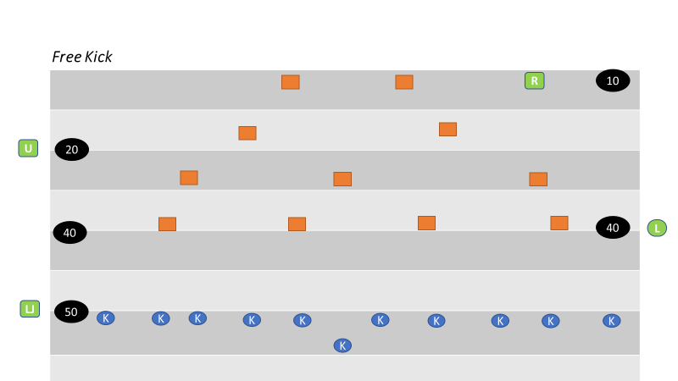

  - Onside Kick
    - The Linesman and Line Judge assume their regular positions while the Referee establishes his position based on the deepest receiver maintaining a view of all players. The Umpire moves to share team R’s restraining line with the Line Judge.
    - The Umpire, Linesman and Line Judge should have their bean bags in hand to mark the spot if team K first touches the kick and should be prepared to blow the ball dead if a prone player from either team recovers the kick regardless of whether it has traveled 10 yards.

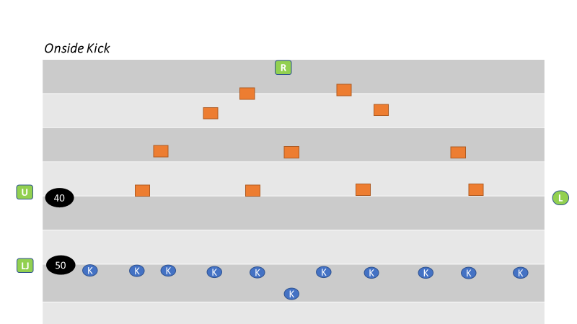

SCRIMMAGE PLAY

- Referee
  - Starting position is on the passing-arm side of the quarterback, approximately 12 to 15 yards deep and about 4-5 yards outside the tight end on the quarterback’s throwing arm side. The Referee should be in an upright stature with a balanced and athletic posture. The Referee is responsible for Team A’s player count and knows how many players are in the huddle. He signals the player count when the huddle breaks, holding it until the offense reaches the line of scrimmage. The Referee will keep the 40/25 second clock. He must develop a consistent tempo for marking the ball ready for play.
- Umpire
  - Starting position is 4-7 yards behind Team B’s line and between the defensive ends in a hands-on-thighs position. The Umpire must be able to see the snapper hands whenever they are on the ball. Until the Referee blows the ready for play whistle, the Umpire must maintain control of the ball by voice or position. He must know which players are on the line of scrimmage in the free blocking zone. He shall note the position of ball between hash marks. He will count Team A and confirm count with Referee (Crew Signal A).
- Linesman and Line Judge
  - Starting position is straddling the line of scrimmage on the sideline. They will use an upright stance while working off the field of play. They each count Team B but no confirmation signal is required.

  - Before the snap, the wing officials identify the eligible receivers on their side of the field and determine legality of the offensive formation. As the widest receiver approaches his position near the wing official, the Wing will indicate the location of the line of scrimmage by placing his up field foot on the line of scrimmage and patting his hand on his thigh. After the receiver has established his position, the Wing official will signal and declare the receiver’s position. If the receiver is in the back field the wing will extend his arm toward the offensive backfield (Crew Signal I). If he is on the line of scrimmage the wing official shall point with the up field arm to the ground (Crew Signal J).

GOAL LINE GOING IN

A touchdown signal is given only by an official who actually rules on the play. Never mirror a touchdown signal if you do not see the action. The crew will find it difficult to overcome two officials making an incorrect ruling.
- Referee
  - Standard starting position and coverage.
- Umpire
  - Standard starting position; however, do not stand on the goal line as this will interfere with the wing’s goal line coverage.
  - On running play between the tackle that results in the ball ending in a pile near the goal line, point to the ball to assist the crashing wings in determining if result is a touchdown.
- Linesman and Line Judge
  - When the ball is snapped inside the 15 yard line, the wing officials should begin coverage movement toward the goal line at the snap. When the ball is snapped on or inside the 5 yard line, the Wings must move immediately to the goal line pylon. If the play moves toward you, back away from the sideline keeping the goal line in view. When the ball breaks the goal line plane in player possession, use a slow confident touchdown signal while continuing to dead ball officiate. There is no reason to rush this signal.
  - On close plays in the middle of the field do not stay on sideline. Move rapidly in toward ball after the play is over. When you determine the progress has resulted in a touchdown, stop your feet prior to signaling a confident touchdown signal. Sell your call! If not sure, move in ‘inside’ the field of play using your feet to mark the progress spot. If you come in on the goal line or in the end zone, everyone will think the ball has crossed the goal line. Avoid pointing to the ground and verbalizing that “he is short” until you have confirmed that the opposite wing does not have a touchdown.

GOAL LINE COMING OUT

When the ball is snapped between the goal line and Team A’s 10 yard line, proper positioning and coverage is necessary to ensure the goal line is covered. When the ball is snapped inside the 5 yard line, attention to the goal line is even more important. This coverage is called Reverse Goal Line Mechanics. The priority is determining if a safety is scored. Covering officials must be alert for the ball becoming dead in the end zone in the possession of the offensive team. A safety signal is given only by an official who actually rules on the play. Mirroring the signal is unnecessary and dangerous.

WHEN THE BALL IS SNAPPED INSIDE THE 5 YARD LINE

- Referee
  - The Referee starts near the end line and wider than normal to provide a better view of forward progress if the quarterback scrambles out of the pocket on a pass play and is stopped near the goal line. The Referee is responsible for the goal line on passing plays along with the facing wing official. The Referee is responsible for the end line.
- Linesman and Line Judge
  - At the snap the wings must move immediately to the goal line and about two yards outside the pylon and then read a tackle for run/pass.
  - On a running play they must determine if the ball gets completely out of the end zone before it becomes dead and stay on the goal line until it is no longer threatened. They must pinch in on the field of play to mark progress or look for the ball near the goal line and pinch in when in the end zone to signal safety. They must work back toward the line of scrimmage if the runner takes them there and square off to identify the forward progress spot. (REMEMBER: The ball must get completely out of the end zone.) If the progress spot is very close to the goal line, the ball is placed at least a foot into the field of play.
  - On a passing play the wing official that is NOT facing the Referee shall retreat towards the goal line at the snap while reading the tackle’s block for run/pass. If pass is read, he changes direction and observes the receivers. The wing official that is facing the Referee remains on the goal line to assist the Referee with goal line coverage and rotates his focus to pass coverage after the quarterback releases the ball.

WHEN THE BALL IS SNAPPED BETWEEN THE 5 YARD LINE AND 10 YARD LINE

- Referee
  - The Referee shall start 10 yards deep and wider than normal. Starting wider and closer to the line of scrimmage will allow the Referee to get a better look at the quarterback who drops back to pass near the goal line and is in danger of being sacked there. This position also provides the Referee a better chance to rule on the quarterback’s forward progress. The Referee is responsible for the end line and the goal line.
- Umpire, Linesman and Line Judge
  - There are no differences from regular scrimmage downs.

SCRIMMAGE KICK

POSITIONING

- Referee
  - The Referee’s position is about five yards outside and five yards behind the kicker and opposite side of the kicker from the Linesman. The Referee should be able to view the snap and the initial block back and the tackle then the action around the kicker before, during and after the kick. The Referee must be ready to move in the appropriate direction if an errant snap leads to a loose ball in the offensive backfield and must have an awareness of the goal line.
- Umpire
  - Deeper is better on scrimmage kicks. The Umpire should start at least 10 yards off the line of scrimmage.
- Linesman
  - The starting position is the same as for other plays from scrimmage.

- Line Judge
  - The Line Judge begins the play three to five yards behind the deepest receiver and wide enough to observe the receiver’s hands. The Line Judge must be prepared to move up field if the kick is short or downfield if the receiver has to retreat. If the deep receiver is near or behind Team R’s 15 Yard Line, the Line Judge must start on the goal line and not move off the goal line unless it is certain it will not be threatened.
COVERAGE

Once the kick is away and the kicker is safe, the Referee takes a quick look to see the flight of the ball. If the kick is toward a sideline, he must be prepared to determine the spot the ball went out of bounds. If the kick is very short, the Referee can identify the out-of-bounds spot by verbalizing the yard line; if the kick is long and goes out of bounds the Referee will take note of the location that the ball landed, the covering official moves past where he thinks it flew out before walking toward the Referee with his hand up — along the sideline — until the Referee chops downward, telling him to halt. The wing officials should always spot the ball on a whole yard line. The wing official should not always expect the Referee to help line up a scrimmage kick that has gone out-of-bounds in the air. If the Referee has a hand up, that means he can help. You may have to create a spot, but once you choose a spot, sell it!
On blocked kicks, the Linesman will determine if the ball crosses the Line of Scrimmage. The Referee and Linesman should be ready to rule on the recovery and observe the advance of any player who runs with a recovered ball.
If the kick is short, officials must know who touched a loose ball; if the kicking team is first to touch the kick, a bean bag should be dropped at the yardline of the touching.
During a return, the Line Judge is responsible for covering the runner until he is transferred another official. If the runner breaks into the opposite side zone, coverage transfers to the Linesman and the Line Judge cleans up behind the play. The Referee may take over coverage of the runner if the runner breaks off a long return.

- Referee
  - As the ball travels from the snapper to the punter, the Referee should observe the initial block by the near backfield protectors and then shift his focus to any player who becomes a threat to contact the ball or the kicker. If the snap is errant or mishandled, the Referee must be prepared to rule on the legality of any contact with the kicker. He must stay focused on the kicker until all threat of harm has passed. He should alert the defenders when the ball is kicked: “Ball’s away, ball’s away.” Do not move too quickly downfield after the scrimmage kick and keep all players in your view.
  - The Referee must be ready to move in the appropriate direction in case of a blocked kick. On blocked kicks, the Referee should be ready to rule on the recovery and observe the advance of any player who runs with a recovered ball. If the kicker runs with the intent to kick rugby style, the Referee must move with him and note the nearest defenders to rule on the legality of any contact.
  - The Referee must strive for a position where he can watch both the kicker and the flight of the ball. Once it is clear the ball will not go out of bounds in flight, the Referee should no longer be concerned about the ball.
  - If the kick goes out-of-bounds in flight, the Referee will raise his hand to line up the kick for the covering official. If there is continuing action on the kicker, the Referee must disregard the preceding and let the covering official get the out-of-bounds spot by himself.
  - If the receivers begin a return, the Referee should move slowly downfield; if the runner breaks a long return, the Referee may ultimately assume responsibility for the runner. The Referee has responsibility of the goal line.
- Umpire
  - For the goal line and the sideline opposite from the Linesman. Referee will get an inside-out look regardless of which sideline is involved since the appropriate wing official has sideline responsibility from end line to end line.
  - The Umpire is responsible for the initial action on the snapper and for blocks by all interior linemen and the widest players (gunners) opposite the Linesman. After the ball is kicked and all linemen/backs have cleared his position, he should move slowly downfield along the hash opposite of the Referee keeping as many players in view as possible. The Umpire should be aware of a short kick or a partially blocked kick. The Umpire must observe the action around the ball and help determine if the ball is touched first by Team R beyond the neutral zone and prepare to drop a beanbag if first touching occurs by K. On a return, the Umpire has responsibility for blocks between his position and the runner.
- Linesman
  - The Linesman observes the initial line charge and is responsible for encroachment/false start. The Linesman is primarily responsible for determining if the ball crossed the neutral zone and doesn’t move downfield until the ball crosses it. The Linesman’s focus should include blocking/restraint by Team R on his side of the ball including the ‘gunners’ followed by coverage around and in front of the kick receiver. The Linesman is responsible for his sideline from end line to end line and for covering the runner when the return is to his area. If the run is to the opposite sideline, he should clean up behind the play.

  - If the ball is punted near the end zone, the wing officials must be alert for a blocked punt or a broken play and may have to cover action involving the goal line.
  - If the kick is blocked, the Linesman has primary responsibility for determining if the ball is touched first by Team R beyond the line and whether the spot of a recovery is beyond or behind the line. The Linesman must also be cognizant of a fake punt. If the kicker initially starts to run before deciding to kick, the Linesman may have to rule whether the punter was beyond the line when the ball was kicked.
  - The distance the Linesman moves after the kick is dependent on the length of the kick, but each should strive for covering approximately half the distance between the line and the end of the kick.
  - If a scrimmage kick goes over the receivers head the Line Judge shall cover the ball and the Linesman will observe the receiver for any blocking after a fair catch signal (valid or invalid).
- Line Judge
  - All deep receivers are the responsibility of the Line Judge. Once the ball is kicked, he judges the validity of any fair catch signal, moves with the receiver and maintains a position to rule on catch vs. muff. He should observe the receivers and the players around them rather than the ball as it flies downfield. Remaining far enough away from the receiver to retain a wide-angle view and moving in at a controlled pace, with eyes searching, once the receiver has completed the fair catch helps the Linesman look for illegal action around the receiver. In such cases, it is also a good idea not to have the whistle in the mouth; it is possible for a fair catch to be muffed and a whistle blown before the ball dribbles loose from the receiver’s grasp.
  - Once the receiver catches the kick, he must watch the players who approach the runner and should track the ball with his peripheral vision. The Line Judge is responsible for his sideline from end zone to end zone and for covering the runner until he is transferred another official.
  - If the ball is kicked over the head of the deepest receiver, the Line Judge must retreat and not allow any player to get behind him. He will release the receiver to the Linesman and proceed to cover the ball.
  - The Line Judge has sole responsibility for determining if a touchback occurs or the momentum exception applies.
  - The Line Judge must bean bag the spot where the kick ends unless that spot is also the dead-ball spot in which case the Line Judge will stop the clock and hold the spot. That spot may be used for post- scrimmage kick penalty enforcement.

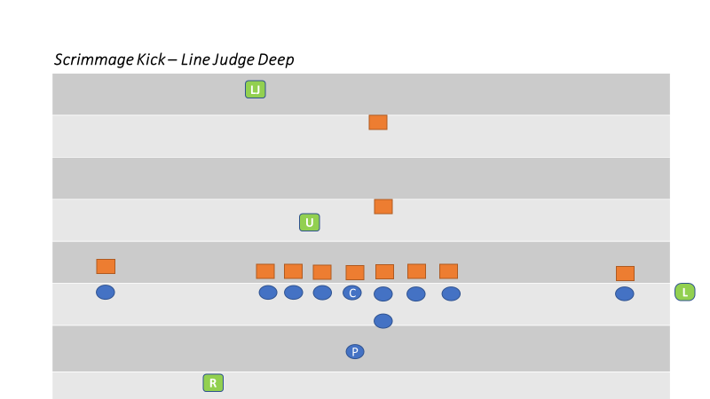

SCORING KICK PAT/FIELD GOAL

POSITIONING

- Referee
  - The Referee’s starting position is even with and facing the front of the holder. It is permissible for the Referee to line up 1-2 yards behind the yard line of the holder to get a better view the snap and the initial block by the end and back on his side and then the action around the kicker before the kick. The distance from the holder may vary depending on personal preference, keeping in mind that the Referee is responsible for the sideline and the pylon behind him if there is a run or pass to that side.
  - The Referee rules on roughing the holder and kicker.
  - The Referee must be ready to move in the appropriate direction if an errant snap leads to a loose ball in the offensive backfield and must have an awareness of legality of the holder’s position and actions during a fake.
  - The Referee signals the score to the press box after confirming the signal from the officials under the upright.
- Umpire
  - The starting position is under the upright opposite the Referee. The Umpire is responsible for counting the offense; checking the numbers of the players on the offensive line and reminding Team R players about illegal contact on the snapper.

- Linesman or Line Judge
  - The wing official that the Referee faces remains in his normal position straddling the line of scrimmage and off the field. The opposite wing official (from behind the Referee) joins the Umpire at the upright nearest his sideline and rules on his upright and the cross bar. The wing official that remains on the line of scrimmage must be prepared to rule on the entire goal line if the try turns into a run or pass play.
  - In order to avoid confusion during a last-second field goal attempt, the positioning of the wings must be a point of emphasis during the pregame.
  - Umpire and Wing under upright: After ruling determining successful or unsuccessful, take two steps straight forward announcing “yes yes” or “no no” then signal. Officials shall hold their signal until the Referee has made eye contact.

SCORING KICK

COVERAGE

- Referee
  - The Referee must watch the holder receive the ball and the action of the holder’s knee as the rules distinguish between the lifting of the knee during a muff and after possession of the ball has been obtained. The position of the knee is also critical if the ball is subsequently passed or handed off.
  - After the kick, the Referee is responsible for ruling on contact on both the kicker and holder. Once he is confident the kicker and holder are no longer in danger of being contacted, the Referee should dead-ball officiate for two-three seconds and then look to the deep officials to learn the result of the kick. The signal should be relayed to the press box once players have separated.
  - If a kick Try is blocked, the Referee should blow his whistle immediately as the play is over and the ball is dead; however, a blocked field goal remains live. Communication with the crew prior to the kick regarding the live ball/dead ball status of a blocked kick or a kick that fails to reach the goal line is essential.
  - In cases of a fake or a broken play, if a run or pass develops to his side, the Referee is responsible for sideline coverage including the pylon (acts as the wing). If Team R recovers the ball and runs for a score, the Referee is responsible for his sideline all the way to the goal line.

- Umpire
  - Initially, the Umpire rules on the legality of the snap. His primary responsibility then is action on the snapper. He must also watch the blocks by the snapper and guards. The Umpire should step towards the snapper after the try kick with a vocal presence to reduce the chance of unnecessary acts.
  - If a blocked kick or fake results in a play toward the goal line, the Umpire has the inside-out look at blocks near the point of attack and can help with goal line coverage on the open side of the field.

- Linesman and Line Judge
  - The wing official on the line of scrimmage has sole responsibility for encroachment/false starts.
  - If the Try or FG becomes a run or pass play this wing has sole responsibility for the goal line and the line to gain. He can also help rule on ineligibles downfield on fake kicks that result in a pass that crosses the neutral zone. When a runner approaches the goal line, the wing official will move to the goal line to rule on the potential score.
  - After the kick, the wing official must pinch-in toward the offensive and defensive linemen to dead-ball officiate and use his voice to encourage players to unpile and return to the sideline. If the kick falls short of the goal line, the wing official must rule on touchback, momentum and a kick return by Team R.
- Wing Under Upright
  - This wing official is responsible for ruling whether the ball passed inside or outside the upright. When a successful kick passes the upright or when the ball breaks the goal line plain and it is obvious it will not score, the Wing sounds his whistle. The Wing official should pronounce his ruling verbally using “yes, yes” or “no, no, no.” The Wing official shall then take two steps straight forward into the end zone and signal. Hold the signal until the Referee makes eye contact and repeats the signal to the press box.

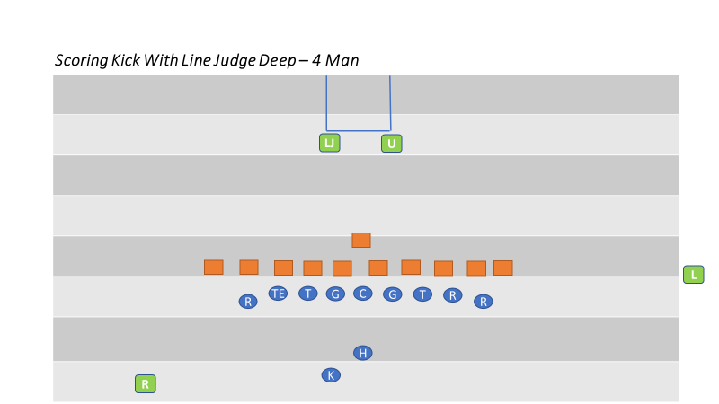

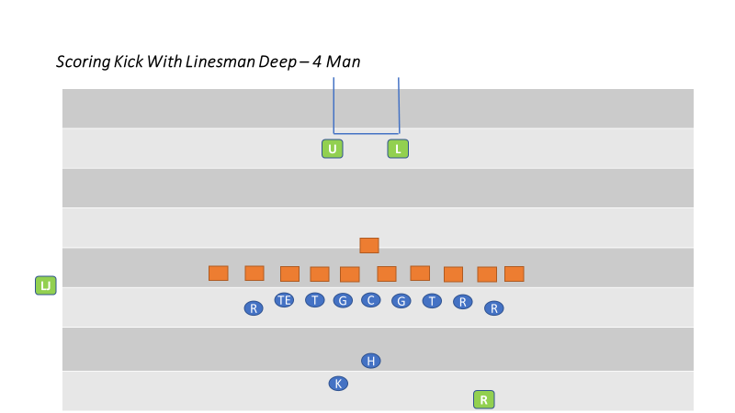

SWINGING GATE FORMATION

The Swinging Gate formation is occasionally used during a Try. The Referee is encouraged to ask during the pregame discussion with the head coach if he has any trick plays including the use of the Swinging Gate. If so, the crew should subsequently discuss the use of this mechanic in detail.

Some plays that are typically run out of this formation include:

- An angled long snap (not between the snapper’s legs) to a running back behind the linemen with a subsequent bull rush to the goal line.
- The holder receives the snap and passes to an eligible receiver (by position and number) which can include the snapper.
- The holder pitches the ball to the kicker and becomes a blocker.

- Referee
  - The Referee faces the holder from a position about three yards behind and five yards to the side of the kicker. The Referee should be able to view the snap and the action around the kicker before the kick. The Referee rules if the ball passed inside the upright to his side and signals the score to the press box if confirmed by the signal from the Umpire under the post.
  - The Referee must watch the holder receive the ball and the action of the holder’s knee as the rules distinguish between the lifting of the knee during a muff and after possession of the ball has been obtained. The position of the knee is also critical if the ball is subsequently passed or handed off.

- Umpire
  - The Umpire’s initial position is seven yards deep in the end zone, favoring the side opposite of the Referee. If Team A shifts into a normal kick try formation, the Umpire will take a position behind the upright. He should vocalize to the Team B players to avoid illegal action against the snapper. The Umpire is responsible for ruling whether the ball passed inside or outside the upright on his side as well as whether the ball cleared the crossbar.
- Linesman and Line Judge
  - The wing’s starting position and coverage is the same as normal scrimmage plays. Each moves to the goal line at the snap as for any other goal line coverage situation. If Team A shifts into scrimmage kick formation, the wings shall shift to the goal post.

SECTION 29
3 PERSON MECHANICS SUPPLEMENT MANUAL

The 5-Person Mechanics Manual contains the mechanics and philosophies for officiating football in CFOA and provides the foundational information necessary to officiate a 3-Person game. The mechanics contained in this supplement are intended to assist with the transition from 5-Person mechanics to 3-Person mechanics without a significant amount of change. Officials must read and understand the 5-Person Mechanics Manual prior to utilizing this supplemental information.

NOTABLE DIFFERENCES BETWEEN THE 5-PERSON AND 4-PERSON AND 3-PERSON MECHANICS:

1. Referee will time and communicate the 40/25-second play clock to the quarterback and coach
2. Wings will count Team B players and the Referee will count Team A players
3. Pregame communication with clock operator in press box is done by the Line Judge
4. Keys
5. Positioning and Coverage of Free Kicks, Scrimmage Kicks and Scoring Kicks
6. Scrimmage Play Coverage

GAME ADMINISTRATION – 3-MAN

ON FIELD PRE-GAME DUTIES
- Referee and Line Judge confer with coaches and check game balls.
- Be businesslike and cordial but not overly friendly with the coaches.
- Referee check equipment and taping.
- Head Linesman instructs chain crew.
- Line Judge instructs clock operator.
- All check field for holes and unsafe conditions.
- Line Judge and Head Linesman get captains to respective sidelines for coin toss.

COIN TOSS PROCEDURES
- Line Judge and Referee escort captains from press box side to center.
- Head Linesman escort captains from chains side to center.
- Line Judge introduce captains to Referee on sidelines, Head Linesman introduce captains to Referee in center of field.
- Line Judge and Head Linesman make certain your team is either in their respective team box or in their end zone during the coin toss.
- After meeting in center of the field, Line Judge and Head Linesman will move to 45-yard line.
- Referee will face the clock.
- Referee will introduce the crew.
- Referee instructs captains. Visiting captains will call coin toss. The visiting captain is required to indicate heads or tails prior the toss of the coin.
- Referee will indicate winning captains and choice, or option deferred.
- If the captain’s choice is to defer, the Referee will face the press box and give the proper signal. After the toss, all meet and record results, then jog to kickoff positions.
TIME OUTS
- Referee observes Team A huddle and covers the ball and spot.
- Head Linesman with chain crew and covers team on sideline.
- Line Judge covers team on sideline opposite chains and times the time out.
- All officials verify number of time outs and record.

MEASUREMENTS
- Referee
  - Check with crew for possible first down.
  - View ball at dead ball spot to verify a measurement is necessary.
  - If measurement is necessary, stop clock and signal official’s time out. Have the official with the spot place the ball on the ground.
  - Have the Head Linesman and chain crew bring in the chains. Mark the spot for Head Linesman to place the chain clip. Move to observe measurement.
  - If first down, signal. If not first down, signal down and distance. If the ball is in a side zone, the Referee shall use the chains to place the ball at the inbound spot.
  - When the chains are in place, mark the ball ready for play, wind clock or no wind depending on status of clock before official’s time out.
- Head Linesman
  - Move quickly to forward stake, signal to Referee if a definite first down.
  - To measure, instruct box person to place box at the forward stake.
  - Ensure the clip is on the proper five-yard line and securely fastened to the chain.
  - Holding the clip, jog onto the field with the chain crew and place the clip on the spot on the field indicated by the Referee.
  - If first down, drop clip, move to sideline and mark spot. If not a first down, return clip to the correct spot on sideline.
- Line Judge
  - Alert Referee to plays ending close to first downs.
  - Stop clock if obvious first down, then alert Referee.
  - Clear area of players. Take the forward stake from the chain crew and stretch the chain after the Head Linesman declares the chain is set.

QUARTER
- Referee
  - Be aware of last minute of play. If the ball is not in play when the clock runs out, step in to prevent the snap.
  - Announce end of quarter, record the down and distance and release the Head Linesman.
  - Check to make certain the down, distance and yard line are correct.
  - When officials are ready and the Line Judge indicates the intermission is over, declare the ball ready for play.

- Head Linesman
  - Prepare the chains to move to the new location on the Referee’s signal. Make certain the clip is located appropriately on the nearest yard line and take note.
  - Grab the clip and chain at the same time, reverse the chain crew, jog to the new position and place the chain on the new spot.
  - Place your heel at the front of the ball for the down box.

- Line Judge
  - Prepare to go to the spot where the ball should be put into play at the start of the next quarter.
  - Time the one-minute intermission and notify Referee when 55 seconds have elapsed.
  - Jog to the new spot on the opposite side of the field and spot the ball.
  - Stay between the teams to show presence as you move to the new spot.
  - Confirm that the Referee and Head Linesman have the ball and chains at the right spot.

HALFTIME
- As soon as teams leave field, the Referee will look at the timer and wind to start the half-time clock.
- All officials meet and review first half.
- Flank officials will extend a 5-minute courtesy call to each team.
- Head Linesman or Line Judge will confer with the coach who has the second half decision on which way they would like to kick the ball. Do this as they either leave the field or when you provide the 5-minute courtesy call.
- Provide the information to fellow officials during mandatory three-minute warm-up period or before the crew leaves for the appropriate kick-off positions.

CALLING FOULS
- Do not pick up or move flag until foul has been enforced.
- Make certain that box and chains are not moved until penalty is enforced.
- Do not put hands on or point at players when calling fouls.
- If player is disqualified, official making the call will be accompanied by the Referee to the player’s sideline to report to the coach the ejection and reason for ejection.
- If Referee is the official making the call, he will be accompanied by the Flank Official on the player’s sideline.
- Official calling foul relays foul information to the Referee.
- Refer to the offending team by school/team name and offense or defense.
- Give number of offending player, note position of ball, live ball/dead ball, loose ball etc.
- Referee will give a preliminary signal to the press box, then explain options.
- After Line Judge stepping off penalty or Referee signals declination, give signal to chains side. Then signal to press box sideline. If fouls are announced by the stadium announcer, it’s not necessary to signal both sides.

FREE KICK MECHANICS – 3-MAN

PRE-KICK MECHANICS
ALL OFFICIALS – HUSTLE TO POSITION!
- Referee
  - Take position at the goal line (or as appropriate behind the deepest receivers) in the middle of the field.
  - Count the receiving team (use eyes not fingers). Signal accordingly for less than/greater than/equal to 11 players.
  - Signal Head Linesman to confirm count by extending your arm with a closed fist.
  - Upon ready signal from Line Judge, if the receiving team is in position, blow the ready for play whistle.
  - On anticipated short free kicks may cheat-up if possible.
  - On a free kick following a safety, take position five-yards deeper than the receiver(s) and not further from the goal line than the 20-yard line.
- Head Linesman
  - Go to your position on the receiving team’s restraining line at the sideline. Have your team on the field within one minute following a score.
  - Count the receiving team (use eyes not fingers). Signal accordingly for less than/greater than/or equal to 11 players. Confirm with Referee.
  - Hold bean bag in hand. Anticipate first touching.
  - Provide ready signal only when count is correct, receiving team is in position, sideline is clear, you are ready, and the Line Judge signals he is ready.
- Line Judge
  - Time the one-minute intermission following a score. Alert Head Linesman after 45 seconds.
  - Have your team on the field within one minute following a score.
  - Make certain the ball is inflated properly, has “pebble grain” and white stripes.
  - Count the kicking team (use eyes not fingers). Signal accordingly for less than/greater than/or equal to 11 players. Give kicker the ball and tell him not to kick until the Referee blows his whistle.
  - Go to your position on the kicking team’s restraining line at the sideline. Signal ready to the Head Linesman who will then raise arm for ready signal.
  - Upon ready signal from Head Linesman, provide ready signal to Referee (K may be in the huddle when you signal).
  - Hold bean bag in hand. Anticipate first touching.
  - Provide ready signal only when count is correct, kicking team is in position, sideline is clear, you are ready, and the Head Linesman signals he is ready.

FREE KICK FOLLOWING A FAIR CATCH
- Referee, position with the kicker.
- Head Linesman, position on the kicking team’s restraining line.
- Line Judge, position under the goal post.

DURING THE FREE-KICK MECHANICS
- Referee
  - Identify your keys, the nearest receivers.
  - Consider your areas of protection; goal line.
  - Quickly check the direction of the ball (short, long, left, or right). If it is a short kick, move up and provide dead-ball support. On a kick out of bounds, move toward the out of bounds spot and throw your flag if in your zone.
  - When the ball is touched, start the clock (two winds). When the kick breaks the goal line plane (touched or untouched), signal touchback.
  - Observe action around the receivers and watch the middle players of the receiving team moving down the field. Cover blocking and other action on and by your keys.
  - As the runner moves further downfield, assume coverage in behind the ball carrier.
  - Maintain an inside-out view of the action around the field.

- Head Linesman
  - Identify your keys, the nearest six players of the kicking team.
  - Watch the receiver’s restraining line for encroachment by receiving team.
  - Quickly check the direction of the ball (short, long, left, or right). If it is a short kick, look for first touching by kicking team and use your bean bag as needed.
  - On a kick out of bounds, throw flag to the out of Bounds spot. If the team on your sideline is the offended team, get the enforcement choice from the coach and advise the Referee.
  - Observe action on the kicker. Cover blocking and other action on and by your keys.
  - As the runner nears, assume coverage in front of the ball carrier. Be on the goal line before the runner. Maintain an inside-out view of the action around the ball carrier.
  - Drift down the field to assume coverage of the runner and take all the way to the goal line. You have progress.
  - On plays to the opposite side, mirror Line Judge movement downfield.
  - With wide vision, watch blocking and look for illegal acts. Use cross-field mechanics where appropriate.
  - When the runner is downed in your coverage zone, stop the clock. Place the ball at your feet until the incoming ball is spotted.
  - Duplicate other official’s signals if play does not end in your coverage zone.

- Line Judge
  - Identify your keys, the nearest five players of the kicking team.
  - Watch the kicker’s restraining line for encroachment by the kicking team.
  - Quickly check the direction of the ball (short, long, left, or right). If it is a short kick, look for first touching by kicking team and use your bean bag as needed.
  - On a kick out of bounds, throw flag to the out of bounds spot. If the team on your sideline is the offended team, get the enforcement choice from the coach and advise the Referee.
  - Drift down the field to assume coverage of the runner and take all the way to the goal line. You have progress.
  - On plays to the opposite side, mirror Head Linesman movement down field. With wide vision, watch blocking and look for illegal acts.
  - Use cross-field mechanics where appropriate.
  - When the runner is down in your coverage zone, stop the clock. Place the ball at your feet until the incoming ball is spotted.
  - Duplicate other official’s signals if play does not end in your coverage zone.

FREE KICK COVERAGE MECHANICS
- ALL OFFICIALS – Keep play and runner boxed in and sidelines covered at all times.

- RETURNS DOWN THE CENTER OF THE FIELD
  - Referee – Cover the secondary areas and view blocking and other illegal activity.
  - Head Linesman and Line Judge – Keep the runner boxed in between you. View the action immediately around the runner.

- RETURNS INTO THE HEAD LINESMAN SIDE ZONE
  - Head Linesman is responsible for the runner and action immediately surrounding the runner.
  - Head Linesman will cover the action in front of the runner, viewing blocking and other illegal activity.
  - Referee will cover behind and to the side of the runner, keeping a distance to view activity by other players not around the play.

- RETURNS INTO THE LINE JUDGE SIDE ZONE
  - Line Judge is responsible for the runner and action immediately surrounding the runner.
  - Line Judge will cover the action in front of the runner, viewing blocking and other illegal activity.
  - Referee will cover behind and to the side of the runner, keeping a distance to view activity by other players not around the play.

- POINTS OF EMPHASIS
  - There should always be two officials covering the secondary areas away from the ballcarrier.
  - All officials should dead ball officiate after the play.
  - All officials will hustle and efficiently prepare for the start of the next series.
SCRIMMAGE PLAY MECHANICS – 3-MAN

PRE-SNAP MECHANICS
- Referee
  - Signal upcoming down to Head Linesman and then to rest of the crew.
  - Retrieve the ball from the runner or obtain a new ball from another official or ball boy. Hustle outside the inbounds marks as needed to assist in retrieving the ball and spotting it.
  - Make visual contact with all officials to determine if they are ready.
  - Indicate “Ready for Play” with short whistle and hack or long whistle and wind two times.
  - Count Team A players.
  - Count Team A players numbered 50-79. Know ineligibles.
  - Assume a position about 12-yards behind the neutral zone and outside the tackle on the quarterback’s throwing arm side.
  - Count Team A players (in huddle, if possible) and signal.
  - Identify formation and observe initial keys: snap, quarterback, false start, QB hard count and head bob, tackle on opposite side.

- Head Linesman
  - Signal upcoming down and confirm with Referee and Line Judge.
  - Move box/chains as necessary for the correct down and distance.
  - Assume a position straddling the neutral zone, outside the sideline opposite the Line Judge.
  - Be prepared to indicate Team A line to Team A wide receiver with your foot.
  - Identify formation and signal status of eligible receivers on your side of snapper.
  - Use the prescribed Line of Scrimmage signals on all scrimmage plays. (located in the 5-man manual)
  - Know eligible receivers on your side of snapper and identify your initial keys. Know your eligible receivers.
  - Motion – if motion man is going away from you, have primary responsibility for knowing if motion is legal or illegal. If motion man is coming to your side and motion is forward, call it if you see it.

- Line Judge
  - Signal upcoming down and confirm with Head Linesman and Referee.
  - Communicate with the Referee if necessary, to indicate the status of the game clock on the ready with wind signal at waste or, on the snap with arms crossed at the chest.
  - Assume a position straddling the neutral zone, outside the sideline opposite the Head Linesman.
  - Count team B players, signal when Team A breaks huddle.
  - Be prepared to indicate Team A line to Team A wide receiver with your foot.
  - Identify formation and signal status of eligible receivers on your side of snapper.
  - Use the prescribed Line of Scrimmage signals on all scrimmage plays (located in the 5-man manual)
  - Know eligible receivers on your side of snapper and identify your initial keys. Know your eligible receivers.
  - Motion – if motion man is going away from you, have primary responsibility for knowing if motion is legal or illegal. If motion man is coming to your side and motion is forward, call it if you see it.

RUN MECHANICS – 3-MAN

RESPONSIBILITIES AT THE SNAP
- Referee
  - Observe the snap, then momentarily read the action of the quarterback to determine the type of play.
  - Allow your reads to take your focus to the point of attack, while maintaining primary responsibility for action on and by the quarterback.
- Head Linesman
  - Observe the snap then momentarily read read/pass by observing the block by the near tackle (block toward, pass block, pull, etc.).
  - Locate the ball and the point of attack but do not focus on it.
  - On plays beginning at or within the five-yard line, going into the end zone, move to the goal line and officiate back to the line of scrimmage.
  - On plays beginning at or within the three-yard line, going out of the end zone, move back to the goal line and officiate forward to the line of scrimmage.
- Line Judge
  - Observe the snap then momentarily read run/pass by observing the block by the near tackle (block toward, pass block, pull, etc.).
  - Locate the ball and the point of attack but do not focus on it.
  - On plays beginning at or within the five-yard line, going into the end zone, move to the goal line and officiate back to the line of scrimmage.
  - On plays beginning at or within the three-yard line, going out of the end zone, move back to the goal line and officiate forward to the line of scrimmage.

RESPONSIBILITIES AFTER THE SNAP

- Referee
  - After reading the quarterback, shift your focus to the Team A blockers and action behind the point of attack.
  - Know where the runner is, but he should not be your primary focus once he is beyond the line of scrimmage.
  - If the point of attack is outside the inbounds marks, move to that side while maintaining your view of the action behind and around the runner.
  - If the point of attack is between the inbounds marks, box in from the rear, again focusing on blocks behind at the point of attack and around the runner.
  - After the runner is down, maintain a wide view of the dead ball action. If the play ends out of bounds, hustle to the sideline and ensure players separate and return inbounds. Get the ball to the inbounds line.
  - You are responsible for maintaining control around the pile. Talk to players as they unpile, encouraging them to do so in a sportsmanlike manner.
  - If the ball is dead between the inbounds marks, hustle to that spot while keeping your head up to observe the action around the pile.
  - Your points of interest / keys:
    - False starts
    - Illegal shifts
    - Motion
    - Free Blocking Zone
    - Blocking around runner and by team A backs
    - Illegal acts around runner
    - Reverses and trick plays

- Line Judge and Head Linesman
  - After reading the block of the near tackle, momentarily locate the point of attack and the runner.
  - You always have the progress spot all the way until the runner crosses the goal line. This includes an accurate spot when the runner goes out of bounds.
  - On plays within the 10-yard line, if a play threatens the goal line, be prepared to be at the goal line to make the appropriate call.
  - If the play is away or between the inbounds marks, maintain a wide view of the action while paralleling the progress spot, observing player conduct away from the play.
  - If the play is toward your side, observe blocks in front of the runner until you take over responsibility for the runner.
  - If the runner is headed toward your sideline, allow the play to go past you (move into the offensive backfield, if necessary), then trail the play.
  - If the runner crosses the sideline, hustle to the spot and mark progress.
  - Signal timeout while observing the out of bounds dead ball action. Do not look at the ground. If the runner crosses the goal line and continues out of bounds, signal touchdown while observing all dead ball action.
  - After the ball is dead, close to the dead ball spot. Do not pass players and do not close beyond the near inbounds mark unless:
  - Your points of interest / Keys:
    - When the line to gain is threatened
    - When the goal line is threatened
    - When the ball is loose then recovered
    - Encroachment
    - False Starts
    - Illegal motion, shifts, formations
    - Clipping, blocks in back and use of hands

PASS MECHANICS – 3-MAN
COVERAGE MECHANICS (In addition to Running Play)
- Referee
  - As QB drops to pass, drop back at 45 angle maintaining position behind QB on passing arm side. Observe initial blocks by offensive backs.
  - Look through QB to observe blocking by the tackle opposite you.
  - As QB is threatened and attempts to pass, determine if arm is moving forward.
  - Determine initial direction on all passes when QB takes at least a 3-step drop.
  - On QB scrambles toward LOS, determine forward point where ball is released.
  - Signal if the pass is tipped/touched.
  - Announce “BALL IS AWAY” and protect QB until immediate action is complete or QB moves to participate.
  - You have all calls on QB behind the line of scrimmage.
  - Dead ball officiate.
  - Spot the ball on plays.
  - Anticipate:
    - Forward or backward pass
    - Pass attempt vs. fumble
    - Roughing passer Illegal pass (beyond LOS or intentional grounding)
- Line Judge & Head Linesman
  - Read through key receiver to nearest offensive lineman to read play.
  - Rule on action by and on key receiver during initial action.
  - Following initial action, shift to zone coverage- focus on short receiver.
  - Remain near LOS until pass is thrown unless all receivers are deep, stay underneath the shortest receiver (EXCEPTION: Snap from inside 5-yard line, move immediately to goal line).
  - On QB drops of less than 3 steps, determine initial direction of pass to your side.
  - Maintain Outside-in coverage, move parallel to sideline, responsible for sideline from end line to end line.
  - On catch attempts near end line or near sideline, focus on feet then hands.
  - If pass is caught in bounds and then player goes out of bounds, blow whistle, stop clock, mark spot, continue to officiate – Do NOT give catch signal Do not mark spot of passes caught out of bounds.
  - Responsible for progress up to the goal line.
  - Off-ball officiate on plays away. Come into the hash mark on plays into the opposite side zone.
  - Dead ball officiate.
  - Anticipate:
    - Holding
    - Pass interference
    - Catch/No-catch
    - Unnecessary contact / Personal fouls
    - Forward/backward pass
    - Illegal participation

PASS RECEIVER COVERAGE KEYS
Definitions
- Receiver – End or back lined up outside of offensive tackles.
- Strength of the formation - Determined by the number of eligible receivers on a particular side of the offensive formation.
  - The strong side is the side with the most eligible receivers outside the tackles.
- Tight end - The end man on the line of scrimmage lined up no more than 4 yards from the nearest offensive lineman. If he is lined up wider, then he is a split end.
- Back in the backfield - A player in the backfield between the tackles at the snap
- Trips - Three or more receivers on one side of the offensive formation outside the tackles.
- Widest receiver - If players are stacked one behind another, the one nearest the line of scrimmage is considered to be the widest.
- The flank officials key on the eligible players of the offensive formation on their side of the field.

SCRIMMAGE KICK MECHANICS – 3-MAN
PRE-KICK MECHANICS
- Referee
  - Position to the Line Judge side of the field and slightly behind the kicker (approximately 7-yards to the side and 5-yards deeper than the kicker).
  - Count the kicking team and confirm with the Head Linesman.
  - View the lineman and know numbering exceptions.
  - Tell the receiving team lineman “DO NOT HIT THE SNAPPER”.
  - Look quickly to see if the snapper was hit at the start of the play.
- Head Linesman
  - Position on the line of scrimmage in front of the down marker.
  - Count the kicking team and look for confirmation from Referee that he has eleven players.
  - View formation to see that they have at least seven (7) players on the line of scrimmage.
  - View the position of the outside kicking team players.
  - Know who is eligible to catch a pass or go down field prior to the kick.
- Line Judge
  - Position slightly behind and to the side of the deepest receiver on your side of the field (approximately 5-7 yards to the side and 3-5 yards behind the receiver).
  - If two receivers, field position may require you to take a position between the receivers.
  - On kicks from inside the receiving team’s 40-yard line, take a position on the goal line.
  - Count the receiving team and confirm.
  - View the position of the outside kicking team players.
  - Know who is eligible to catch a pass or go down field prior to the kick.
  - Provide fair catch instructions to the receiver(s) if possible.
  - Hold a beanbag in your hand.

DURING THE SCRIMMAGE KICK MECHANICS
- All Officials
  - Strange things happen on kicks. Be mentally prepared for various scenarios based on your position.
- Referee
  - Watch action on the SNAPPER and watch for ineligible players downfield.
  - Normal Kick –Watch blocking by the Team A backs and protect the kicker.
  - Stay with the kicker until all is clear.
  - Be the last official down the field and box in all players from behind with wide vision.
  - If the return breaks through defense, be prepared to take the runner all the way to the goal line.
  - Bad Snap - When there is a bad snap on a scrimmage kick and the play goes deep into the backfield, you will follow the ball back.
  - Kick Out of Bounds – If the kick goes out of bounds in flight, line up the out of bounds spot with covering official by signaling with a hack.
  - After the Play - Indicate to HEAD LINESMAN when to move chains, hustle to the new spot and indicate first down and direction of ball.
  - At the end of the play DEAD BALL OFFICIATE. Spot the incoming ball to be ready for play.
  - POINTS OF EMPHASIS:
    - Fake kicks
    - Bad Snaps
    - Blocked Punt
    - Roughing or Running into the Kicker; Incidental Contact
    - Illegal Blocks Illegal
    - Use of Hands
    - Clock Status before and after the play
- Head Linesman
  - Look to see that the ball has been kicked and quickly see where the ball is headed (i.e. short, long, right, left). DID THE BALL CROSS THE LINE OF SCRIMMAGE, HIT THE GROUND OR A PLAYER?
  - Normal Kick – View the blocking and action around the kicking team’s eligible players and view line action until the ball clears. After the ball has crossed the line of scrimmage, quickly release down the field and parallel the play from the outside with wide vision.
  - Continue to watch the action as the players and ball move toward the receiver. Observe blocking down the field and in front of the runner.
  - Mark first touching with a bean bag.
  - Bad Snap – When there is a bad snap on a scrimmage kick and the play goes deep into the backfield, (the Head Lineman will then have kick crossing or not crossing line).
  - Kick Out of Bounds – On kicks out of bounds, you are responsible for your sideline. Line-up deeper than where the ball went out of bounds on the sideline (no deeper than the goal line) with outside arm straight above your head. Make eye contact with Referee and begin to walk toward the original line of scrimmage. The Referee will hack when you have reached the out of bounds spot.
  - You are one of the covering officials, at the end of the play, spot progress and square-up with the Line Judge, stop the clock and signal direction of the team in possession.
  - DEAD-BALL OFFICIATE. If you are holding the spot, cover the ball until you are relieved by another official.
  - Look to the REFEREE for confirmation to move the chains.
  - POINTS OF EMPHASIS:
    - Blocking Touching of ball; beyond line of scrimmage
    - Illegal Kicking
    - Interference
    - Muff and First Touching Violations
    - Ineligible players downfield
- Line Judge
  - Look to see that the ball has been kicked and quickly look to see where the ball is headed (i.e. short, long, right, left).
  - Normal Kick – View the receiver and run up to be even with the receiver as he prepares to catch the ball. Your only view is the receiver and stay to the side of him by 5-7 yards.
  - Look to see that the receiver catches the ball cleanly and that there was no kick catch interference or to rule on fair catch.
  - Drop your beanbag where the kick ends. Remember that the kick ends when any player gains possession or when the ball becomes dead.
  - If the kick crosses the goal line, blow your whistle and signal touchback.
  - Keep the runner between you and the Head Linesman. You are responsible for coverage of runner from an inside-out view your side of the field. Your distance should be about 10-15 yards from the runner.
  - You have progress.
  - Fair Catch - View the receiver and run up to be even with the receiver as he prepares to catch the ball.
  - View the fair catch signal (valid or invalid?). Make certain the receiver catches the ball cleanly and it does not go through his hands.
  - With a confirmed catch, stop the clock and blow your whistle.
  - First Touch Violation – Use a beanbag if there is a first touching violation by the kicking team. Note: there may be more than one spot of the first touching violation.
  - At the end of the play, stop the clock and signal direction of the team in possession.
  - DEAD-BALL OFFICIATE.
  - Kick Out of Bounds – On kicks out of bounds, you are responsible for your sideline. Line-up deeper than where the ball went out of bounds on the sideline (no deeper than the goal line) with outside arm straight above your head. Make eye contact with Referee and begin to walk toward the original line of scrimmage. The Referee will hack when you have reached the out of bounds spot.
  - Communicate possession and direction to the Referee.

  - POINTS OF EMPHASIS
    - Fair Catch Signals
    - Blocking
    - Goal Line
    - Illegal Batting or Forward Handing
    - Muff and First Touching Violations
    - Fair Catch or Kick Catch Interference
    - Ball Out of Bounds in Flight

FIELD GOAL & PAT MECHANICS – 3-MAN

PRE-SNAP MECHANICS
- All Officials
  - Prior to all field goals attempts, all officials should remind themselves of live ball by using the illegal procedure signal (#S19).
- Referee
  - Take a position behind the potential kicker and 2–3 yards deeper than the kicker holder.
  - Beware of a fake field goal or PAT.
  - Be ready to assist in covering to the sideline.
  - Before the snap, observe any linebackers that may be attempting to shoot the gap to block the kick.
  - You have responsibility for the uprights and whistle.
  - Before the snap, check for any illegal locking of legs by offensive linemen.
- Head Linesman
  - Take a position on the sideline (on PAT, move in to numbers) and observe neutral zone.
- Line Judge
  - At the goal post opposite the chains Count defense.
  - You have sole responsibility for protection of the snapper.
  - Check for use of numbering exception by Team A.
  - You solely have cross bar.
  - Callout the jersey numbers of eligible receivers
- Swinging Gate
  - All officials will be in their regular positions for a scrimmage down.
  - If team A shifts to a formation normally used for a PAT or attempted field goal, then all officials will assume their appropriate position.

KICK MECHANICS
- Referee
  - Observe the motion of backs within line of vision and cover as usual if a run or pass.
  - Immediately after the snap, shift your eyes to the holder and mentally rule if the holder’s knee was down upon receiving the snap.
  - If it is obvious that the PAT kick has been blocked, blow the play dead immediately.
  - Observe whether kick went between the uprights.

  - Verify with Line Judge whether kick went over the crossbar. Give incomplete signal if kick fails.
  - Turn to press box and Give touchdown signal if kick is good.

- Head Linesman
  - After the snap, observe the legality of the blocks of the backs protecting the kicker.
  - You are responsible for the goal line plane.
  - If it is a pass, observe any illegal lineman downfield.
  - If a field goal is blocked, you are responsible in determining if the kick crossed the neutral zone or the goal line and where it is recovered and by whom.
  - After the kick, sprint in to the hash to dead ball officiate.
  - You are solely responsible if the kicker or holder are roughed or have been run into.

- Line Judge
  - Quickly observe the action on and around the center for potential roughing.
  - Communicate with Referee as to the success or failure of the kick going over crossbar (thumbs up or down).
  - On fake, or broken plays, be ready to cover passes or runs as usual.
  - You are responsible for the goal line.
  - Watch line play, after kick ends. On fake plays, be ready to cover passes or runs as usual.

